In this chapter, I shine the spotlight on the chemicals which are forgotten aides to women and the mechanical household technologies that they used. I assemble case studies of the sodas: sodium carbonate, sodium bicarbonate and sodium hydroxide, and Harpic, a branded product that took over one particular job previously done by sodium carbonate. These chemicals remained available throughout the 1930s to the 1980s, so to provide an example of how household chemicals are regulated I studied a grease removing chemical that started to be withdrawn from all consumer products in the 1980s, carbon tetrachloride. I use branded dry-cleaning product Thawpit based on carbon tetrachloride. I will draw on household manuals, biographical accounts and reminiscences, advertisements and articles in newspaper and magazines, as well as material retained in the J. Walter Thompson (JWT) archive at the History of Advertising Trust because JWT promoted Harpic and Thawpit.

This variety of sources allows me to create a richer picture than any taken alone would, although they all have limitations which I examined more thoroughly in Chapter #. My sources reflect the difficulty behind establishing details about the domestic users. Such ordinary household chemicals have not stimulated diarists and oral history interviewees to either note them down in detail nor wax lyrical about them.[1] Nevertheless, they were present in homes, budgets were expended on bringing them into the home, on advertising them. I chose to examine sodas because although their manufacture and sale has formed a substantial part of histories of Imperial Chemical Industries, Lever Bros, and Joseph Crosfield &Sons, their uses in the home have been largely overlooked and user soften appear only as characterless aggregates in the form of financial incomes. The sodas are mentioned in social histories which include descriptions of housework, but attention here has tended to be on pre-war practices. This means that there is an opportunity to look at the changing availability and identities of these chemicals, as well as cataloguing some of their surprising uses between the 1930s to the 1980s. Saving labour is a major aspect of the use of all the chemicals in this chapter, as is their effects on health and wellbeing of the whole family through cleanliness, in particular household surfaces, garments and in the case of Harpic, the WC bowl.

Household manuals prescribed timetables for efficient work and provided shopping lists of a vast array of different cleaning cloths and brushes, even diagrams of how to store these tools but the near absence of branded goods and relative silence regarding chemicals in the general cleaning cupboard was striking. The stain removal sections of household manuals detail the types of activities and materials experienced in the home and how they changed over time. Knowledge about fabric composition, being able to discriminate between natural fibres, of plant or fruit based stains was supplemented by a working understanding of an increasingly confusing array of combinations of synthetic fibres, and a new barrage of stains from processed foods and work-related tasks. Entries for carbon paper and mimeographic correction fluid, indelible pencils and a variety of inks; indian, marking (based on either silver nitrate or aniline), printing, writing and ballpoint trace a history of office work. Fashions in medicine can be traced too from inclusion and disappearance of iodine, mercurochrome, cod liver oil.[2] These catalogues of messy mistakes made in daily life were especially important when laundering a whole garment was difficult and time consuming or otherwise expensive, essentially spot cleaning was a labour saving activity as the lengthy sequence of manually involved processes involved in cleaning entire items could be sidestepped or at least delayed. As plumbed-in automatic washing machines became increasingly available and synthetic detergents developed to cope with an array of stains at lower temperatures, attitudes to laundry changed. Cowan and others have argued that improvements in washing machines and access to them did not necessarily reduce the total amount of housework, instead causing whole garment laundering to be done more frequently. Thinking about stain removal in particular, machines and increasingly complex detergents were delegated the bulk of the work, reducing the operator's involvement in stain removal to first aid before laundering.

While it is tempting to firmly tie increased textile variety and therefore complexity of fabric care straightforwardly to an increased variety of branded stain removal chemicals, this is not necessarily true. After all, plain old clean water was consistently recommended as the starting point for treating all stains, especially fresh ones. Plus, users could simply avoid fabrics with demanding care requirements, or even discover through disobeying the laundering instructions that they were actually flexible. Nevertheless, there do seem to have been some users who took pride in understanding how to treat stains and in perpetuating the publication of exhaustive tables of advice. The motivation for sustaining this expertise was usually framed in terms of simple economics, as saving the financial cost (and effort) of taking stained items to professionals, rather than necessarily elevating the person doing this task at home to that of professional. The emphasis on cost may have influenced how “proprietary products”, meaning having a tradename, were vaguely referred to in manuals, this vagueness also hints at changes in retail. Formula provided openly in *Chemist and Druggist* would be a given slightly different name by each proprietor who made it up so they could claim it as their own. Phamacist John Newstead demonstrated this with the example of Pine-ozone and Pinozone: although neither listed the ingredients on the label, both referenced the formula PJF 10585 and gave identical instructions for use, identifying the products as the same.[3] Where once a store keeper could have discussed individually which proprietary product a stain removal guide probably referred to, self service shopping changed the relationship between customer and shop staff, as well as the knowledge that both were expected to have about products.

In fact, the recommendations for stain removal remained remarkably consistent and the greatest changes in the chemicals that might be kept in people's homes are better traced through the ubiquitous “poisons and antidotes” table in the household medicine chapter, rather than the pages which laid out best cleaning practices. While the poisoning treatments might not explain what useful purpose the potentially harmful chemicals were kept in the house for, they also represented the dominant form of feared interaction with chemicals, that of acute and fatal poisoning through ingestion. The preoccupation of users and non-users with acute poisoning recurs throughout this thesis, rather than any murky, hard to pin down toxic effects from the long-term, low-level exposure to chemicals. In cases where the poisons were not also medicines at a lower dose, they most often reappeared in domestic manuals as a way to remove stains, either from textiles or hard surfaces.

While the bulk of housework was undertaken using innocuous water, soap, soda and hard work, concern about the control of other potentially dangerous household chemicals has been longstanding. In 1926 E.T. Neathercoat, a former president of the Pharmaceutical Society of Great Britain, opined that “However drastic our poison regulations they will never be fool-proof”. The impetus for his commentary was the Poisons Law newly enacted that year which prevented poisons being sold by chemists unless they were clearly labelled as such. Neathercoat welcomed the sentiment behind improved labelling, but worried about the “ignorance and carelessness” of domestic users, of the “despairing” and about “inquisitive children”. His concern lay chiefly with acids: carbolic, oxalic (salts of lemon), hydrochloric (spirits of salts), sulphuric (vitriol) and nitric. He expressed a view that was published surprisingly rarely, that “If effective for the purposes for which they are sold, all of them are virulent poisons of causing an agonising death”.[4] Neathercoat did not expound upon what exactly was being done in homes with these chemicals, why users chose to keep these potentially harmful chemicals in their possession, how they knew about them or the variety of places other than reputable, responsible chemists that people could obtain them. Other than suicidal users, Neathercoat did not mention other forms of deliberate misuse, despite the high profile (if not frequency) of acid attacks. Neathercoat described users which double as categories fitting for this thesis: “ignorant”, which I interpret as not-knowing, “negligent” and “careless”, which I group together as inattentive, and I adopt his “inquisitive children” as well as “despairing” users. User categories get further discussion in their Chapter # once we have explored the range of chemical case studies.

The first study is of the soda family. Sodas count among some of the most innocuous and the most dangerous of chemicals used at home. Ranked in order of least dangerous to most, these are baking, washing and caustic. Washing soda is closely related to caustic soda and bicarbonate of soda, with soda ash being the basis of production for all three. Soda ash requires common salt and limestone as raw materials. Although soda ash was historically produced by the Leblanc method, the Solvay method also known as the ammoniated brine process, was the principal means of soda production in Britain between the 1930s and the 1980s, and is still in use today. This process was adopted in Britain in the 1860s when the company Brunner Mond built a large plant in Winnington, Cheshire, located to use the natural salt deposits which could be extracted as brine. During the process, brine was mixed with carbon dioxide generated by heating limestone. To ensure a supply of limestone for soda ash production, Brunner Mond acquired shares in the Buxton Lime Firm, in nearby Derbyshire, and that company became part of ICI in 1926, laying the foundation of the Lime Division.[5] There were soda plants elsewhere, such as Thawpit's in High Wycombe, which as well as being a recognisable brand of household chemicals in their own right, also supplied Boots the Chemist shops with loose, unbranded soda.[6]

To illuminate the domestic users and uses of sodas, I compiled Table 1 from news stories and advice columns. Housewives and housekeepers were not the only users, as gardeners also found them handy. Caustic soda was used rarely in comparison to the gentler sodas, but that its strength meant that it was also used for harm by those seeking revenge or to scare. Bicarbonate of soda was able to take the place of washing soda, and while washing soda could be ingested in small amounts without harm, it generally was not substituted deliberately for baking soda. Very often in household manuals, the type of soda recommended was unspecified, which required those undertaking the housework to simply know through experience and common sense regarding the context, that they should use washing soda, or sodium carbonate. The names were more reliably given for the other sodas, caustic soda was too strong and inappropriate for most cleaning tasks, and baking was reserved for culinary and cosmetic purposes.

Alma Chesnut Moore's book *How to Clean Everything* outlined the whole “sodium family” and suggested even more soda types that a housewife could ask her chemist for, including TSP (trisodium phosphate) and sodium perborate, neither of which I have seen mentioned as available alone rather than combined with a laundry detergent in any other publication.[7] Joseph Crosfields & Sons made a double salt of sodium carbonate and sodium silicate which they marketed as Carbosil between the 1890s and 1940s. The chemical identity was never described in adverts or packaging, although the name is an amalgamation of **carbo**nate and **sil**icate, despite any potential for names of cleaning products beginning with carb to be associated with carbolic, the phenol-based disinfectant. Carbosil was borne of finding a profitable use for the volume of caustic soda (then converted to carbonate, washing soda) and waste silicate produced by Crosfields.[8] Users understood Carbosil to be a stronger washing soda, or sometimes bleaching soda, through its grease-cutting, water-softening properties, where textiles washed whiter by the avoidance of soap scum, which is why I am including Carbosil in the discussion on washing soda. Crosfields aimed to set Carbosil apart from common soda, “Why use soda when Carbosil costs no more?” asked adverts that promised to “destroy grease” without harming hands. Soda was believed to be harsh on users’ skin and accordingly soap products, including those made by Crosfield, were advertised as not containing or requiring additional soda. The user was imagined in these adverts to be female, aware and in control of household costs, to want clean crockery and to only dislike washing up because the water got greasy. [9]

Whether branded or not, washing soda was the versatile workhorse in the British home until the 1950s, when more specialised detergents came to dominate the domestic cleaning landscape. Washing soda did not disappear from housekeepers' options, but as shall be shown in this chapter, a combination of influences meant it receded from first choice, to be later reinvented by both users and manufacturers as an alternative, simpler option to the complex, branded cleaning formulations available.

|  |  |  |  |
| --- | --- | --- | --- |
| **Date** | **Caustic** | **Washing** | **Bicarbonate** |
| 1890s |  |  | Medicine cabinet |
| 1920s |  | Make Javelle water: boil 4lb bicarbonate soda in 1 gallon water, then add 1lb pulverised chloride of lime[10]  Clean and stiffen household brushes, clean range and gas cooker[11] |  |
| 1930s | Kill tree stumps, even oak[12] | kill dandelion[13]  Mixed with copper sulphate to treat plant rust, esp snapdragons[14] | Douche - Influence conception: have a boy[15] |
| remove old paint from furniture[16] | Combat bed-bug infestation[17] | Clean vacuum flask[18] |
| neutralise acid from the "wireless accumulator" to stop it burning a hole in the carpet[19] | soothe sore eyes from over-chlorinated swimming pools.[20] | Remove iodine stains from textiles[21] |
| Used to write anti-Semitic slogans on golf course[22] | remove smoke stains underneath mantlepiece[23] | Remove scorch marks textiles[24] |
| Slow coal burning, save fuel[25]  Clean oven, save fuel[26]  Soften water, save soap[27] | Rinse eyes after mustard gas[28]  Remove grass stains from textiles[29]  Clean silk stockings[30] |
| Homemade cleaner inc meths, paraffin, ammonia, borax. [31] |
| Treat mildewed plants "Russian method" [32] |
| Essential larder item[33]  Use less sugar to sweeten fruit[34]  Cook legumes, save meat[35]  First aid kit[36] |
| 1940s | Thrown at person[37] | Mixed with copper sulphate to prevent sand bags rotting[38] | Included in commercial fire extinguisher[39] |
| Winter wash for trees[40] | Make tea appear stronger[41] |
| 1950s | Fish killed by caustic soda in business dispute[42] |  | Mix 1 tsp with ½ teacup malt vinegar to make chilblain treatment[43] |
| A 'last resort' for clearing blocked drains[44] |
| 1960s |  |  | Clean refrigerator[45]  Clean melamine, cheaper than Vim[46] |
| 1970s |  |  | Clean freezer[47] |
| 1980s | Cow and Gate baby food contaminated by extortionist/ blackmailer[48] |  |  |
| 1990 |  | ICI promoted soda crystals as 'environmentally friendly' cleaning product[49] |  |

Table 1: Showing uses as they were recommended and misused.

Very often these household hints or instructions did not give precise measurements of the amount of soda to be used, nor were ratios suggested for the volume of crystals with respect to the volume of solvent. Descriptions such as handfuls, “a little soda” or “a tiny knob”[50] abound in manuals and hints columns, meaning that each person's use and end result depended on their personal interpretation of the instruction. Sometimes more precise detail was provided about the amount which should be used for successful results, as in these examples where the lump of washing soda was described as “about the size of a sixpenny piece”,[51] or “about the size of a walnut”.[52] Carbosil was a brand of washing soda that was powdered, and instructed users they only needed “a sprinkle” but also specified this was “a teaspoonful”.[53] Powders dissolved more easily than lumps and a labour saving quality unique to Carbosil, while the sprinkle related to its packaging (Figure 1). A labour-saving reputation, as well as not being “old-fashioned lump soda”[54] may also explain why it appears in a hypothetical upper-middle class Edwardian Mrs AB’s shopping list, the other branded items were Zebra grate polish, Globe polish and Gold Dust soap powder. Hard soap for washing, scrubbing floors and washing up, starch, blue and bath brick did not have brands specified.[55]

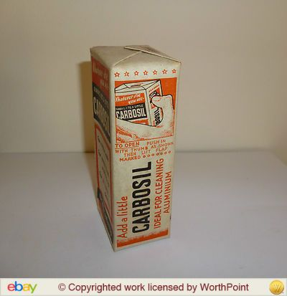

Figure 1 Carbosil packaging picturing an androgynous hand showing how to open the box so the powder could be freely sprinkled. It reads "To open push in with thumb as shown then lift flap marked **ooooooo**”

Social worker and documentarian Reeves recorded the quantities that women routinely bought in 1914, often 7 pounds at a time and 3d was a usual price for this amount,[56] making it popular with working class women as it was cheap, and “made to do a great deal” including children's baths and hair washing.[57] The bulk buying of loose soda steadily reduced over time, with packaged quantities in either tins or cardboard boxes, settling to 2lb packs becoming the main form that soda could be bought in the 1930s. Carbosil drew attention to the bulkiness of ordinary washing soda, indicating that this was a factor users considered undesirable and a reason for choosing the powdered brand. Carbosil came in neat packets priced at tuppence, which the advert pointed out, worked out at “sparkling china and grease-free washing-up for a penny a week” (Figure 2).[58]

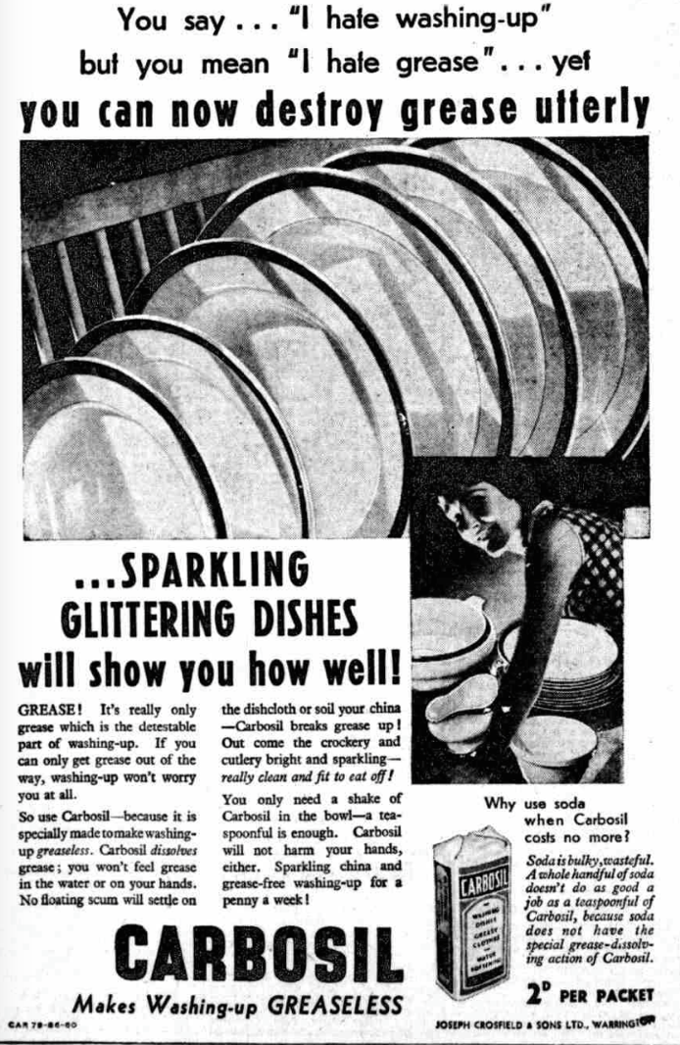 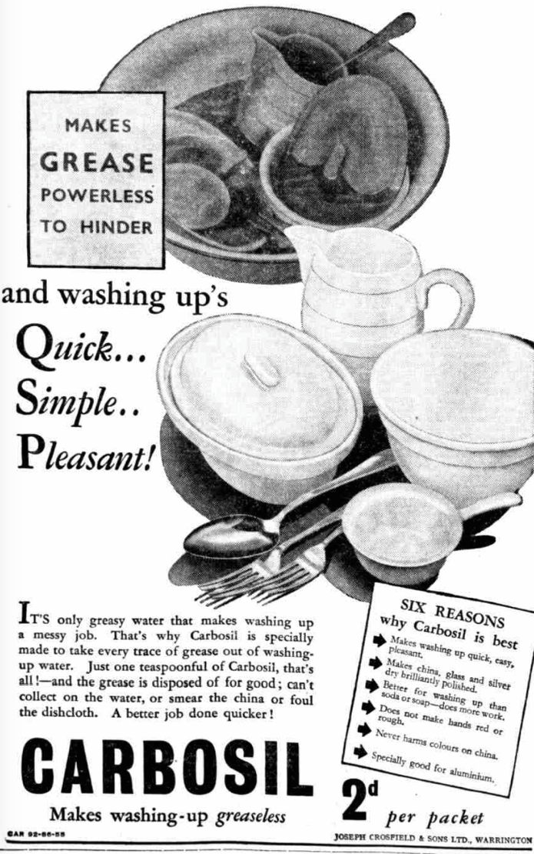

Figure Carbosil (l:1932, r:1933) The adverts give the user some good reasons for choosing Carbosil, and try to make it clear that it is not just common soda.

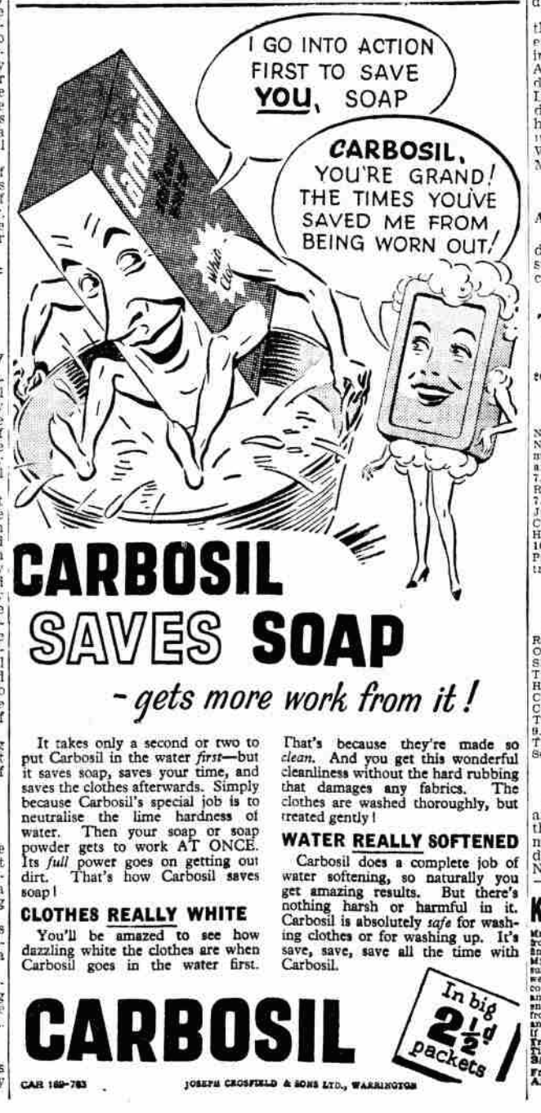 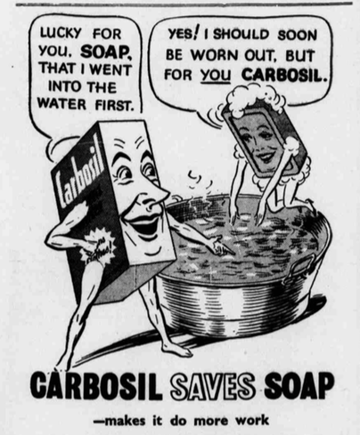

Figure Carbosil (1941). The imagined user is not shown although she is analogous to the foamy soap, rescued but simultaneously made to work harder rather than less by muscular dynamic Carbosil.

World War Two affected Crosfields and ICI through Government control orders on metals and paper, which in turn impacted on the supply of soda to domestic users. An advert (Figure 4) placed by ICI announced that in response to the 1940 paper control order they would forego all prepacking and therefore branding until they could box their soda crystals in cardboard of appropriate quality. The aim of the advert was to reassure soda users that although they could not buy branded boxes, the loose soda they bought from their grocer was the same ICI quality.[59] This was important because soda was frequently promoted through household hints in newspaper articles because unlike soap, soda was not rationed.

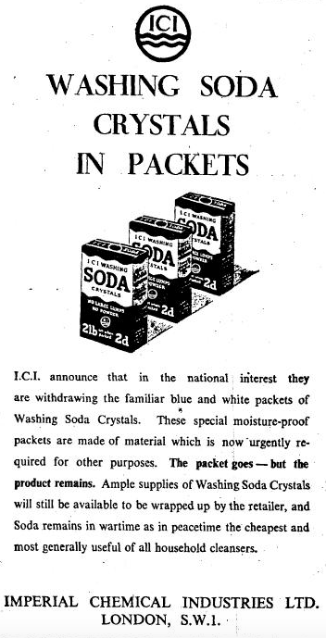

Figure Advert to reassure users that while the branded box was gone, the soda itself was still on sale.

Familiar household sodas and their users, who included a housewife in a homely kitchen scene and a bespectacled counter clerk in a village shop, featured in ICI's profile raising, morale boosting and educational advert series “In The Services of an Industry” which ran from 1942 to 1943. In advert No. 34 “First Aid” readers were told that “in a pinch” when proper equipment was not available they could improvise first aid treatments with sodas (Table 1). These adverts were produced to impress upon the general populace and users of sodas, that the chemical industry was integral to everyday life. No other company attempted to undertake such an ambitious public relations exercise, showcasing generic chemicals rather than trademarked products, but ICI were also a relatively young conglomerate and had also won many wartime government contracts.

While ICI kept their activities in the public eye, Crosfields quietly discontinued Carbosil in 1941 without any goodbye, although they advertised in that same year. A.E. Musson, historian of Crosfields, identified that the decision to stop manufacture followed demands from military procurement officers for increasingly standardised soaps produced by the company as well as glycerine for explosives, diverting energy and raw materials away from civilian products. User demands or at least those of the procurers, lay at the heart of the decision to cease production this otherwise successful household chemical. Musson skirted around why Carbosil production was not resumed after the war, but linked these governmental requirements to a larger picture of disappearing brands and reduction of competition.[60] By 1947 however, a more general shortage of soda ash was having an effect on multiple industries: glass manufacturers laid off workers, a jam jar shortage was feared, laundries had to find substitute water softeners and suggested that housewives would too. Army wives who complained about lack of soda in Germany were told that housewives in Britain experienced the same shortage and indeed, any kind of washing soda became increasingly difficult to get towards the end of 1949.[61] However, other than an occasional letter expressing annoyance at traipsing around town looking for an elusive product, there was little other evidence of household discontent with the general soda shortage. In Portsmouth, an alternative explanation was proffered following council investigations into their local soda crisis: warm weather had caused the crystals to solidify into a single mass, so were unsuitable for sale. The local council assured housewives via the local newspaper that supplies were returning to normal.[62] In early 1950 Olby's store located in Dover saw fit to advertise in the local paper the arrival of a “large consignment of ICI Washing Soda : 2lb cartons 4d”.[63] Declaring the brand as ICI communicated to readers the trusted quality of the product, and indicated that the shopkeeper knew that customers cared about this detail. Ordinary washing soda had been such a common product that it had not warranted large scale advertising, Carbosil as a branded product was promoted in this way. This also marked the point when announcements about soda were taken over by retailers, rather than the manufacturer.

Advertisements from retailers like Olby's demonstrated that washing was no longer such a common product, that it had become difficult to get or that shoppers needed reminding about it and had to be encouraged to use it through price promotions. Later adverts placed by other retailers tended to include soda alongside other household cleaning products, seen in a full page Woolworths adverts that promoted a variety of bargains. “Quality washing soda” was offered, showing a picture of a plain box without any visible distinguishing brand names or manufacturer. The advert continued “You can't get better value anywhere – Woolworths washing soda”, which suggested that the soda was good enough to be branded with the familiar Woolworths brand and therefore the quality of the product could be trusted.[64] In 1965, another Woolworth's advert gave the majority of the full page to images of premium branded cleaning products; Ajax, Brillo, Scotchbrite and Jeyes but listed a selection of further offers in the bottom right corner such as Winfield washing soda, which was Woolworths own “value” brand.[65]

The increasingly lowly position of washing soda can be illustrated in further detail through the situation faced by Boots the chemist. They experienced reduced demand from users, as well as pressures from manufacturers relating to increased costs associated with production and distribution of washing soda. Reluctant to raise the price of such a basic good, Boots questioned whether it was worth continuing to sell loose soda at all, as it was more convenient to sell prepackaged 2lb cartons.[66] In 1967, following further price increases from ICI, Boots chose to forego the loose soda, making this effectively unavailable to domestic users. While their suppliers ICI and Thawpit did not directly substitute more complex products in place of soda, the prepackaged branded soda had to compete with and was out-numbered by alternative, novel products available. Boot's own household products surveys did not even include soda in 1968, focussing exclusively on detergents, soaps and dedicated products such as oven cleaner and toilet cleanser, all identified by company strategists to be growth areas and what domestic users wanted, or should want.[67]The apparent absence of complaint about this change can be explained if new detergents and cleansers addressed dissatisfactions with older products including soda. These were listed in a 1933 Carbosil advert as “makes washing up quick, easy, pleasant, makes china, glass and silver dry brilliantly polished, better for washing up than soda or soap – does more work, never harms colours on china, does not make hands red or rough, specially good for aluminium.”[68] The soda shortage described earlier would have pushed users to find substitutes. When soda became more readily available, not everybody wanted to go back to using soda. Products that incorporated water softeners and grease solvents meant that additional, bulky soda was unnecessary. There were choices of novel products, at not much extra cost, that made dull, tedious tasks easier through the incorporation of soapless detergents, more pleasing or noticeable by the addition of fragrance. Soda could still be obtained by those who really wanted it, such as housekeeper Grace Higgins who was remembered by her daughter-in-law as continuing to use it despite the existence of Fairy liquid.[69]

What can be further discussed in this chapter is the demand from users for value for money and their quest for clearer or more meaningful information about new products. The consumer rights organisation *Which?* was established in 1957, and they compared all manner of new products.

Taking a cue from the successes of *Which?* established in 1957, most newspapers followed suit and ran a column that advised on household products. Trialling new products at home was part of Heather Standring's work as a consumer affairs columnist. She wrote sceptically about dedicated products which promised ever easier cleaning and instead recommended multipurpose products such as 1001 cleaner, or chemicals including washing soda, and extolled the virtues of hard work.[70] Sometimes she demystified products and provided warnings that were not emphasised on the packaging as strongly as she felt should be. While washing soda was often used to clean ovens, Standring warned her readers that Easy-Off oven cleaner contained caustic soda and recommended that they wear rubber gloves.[71]

Soda’s effectiveness did not change but attitudes towards it did. Paralleling the surge in variety and stemming from national financial stresses in the 1970s advice columns and books about housework demonstrated a renewed interest in washing soda as a frugal and general purpose alternative to convenient but expensive branded cleansers in economically difficult times, which firmly associated soda with not being able to afford other products.[72] Instead of being used as an everyday, multipurpose household chemical, soda crystals tended to be used for occasional, dedicated jobs, such as clearing greasy sluggish drains without the worry associated with using caustic soda.

Soda users included those who wanted to become more self-sufficient, which included reducing their reliance on heavily branded and packaged commercial goods. Soda crystals tended to be packaged relatively simply, without much promotion. When ICI rebranded their soda crystals as environmentally friendly in the 1990s, an anti-corporate agenda meant that Greenpeace could not get behind this effort to encourage greater use, and instead drew attention to the manufacturing energy costs behind the product and the company’s history of pollution.[73] Nevertheless, the activist organisation promoted soda crystals without these caveats when it suited them, such as in their *Stepping lightly on the Earth* guide.

Growing environmental concern meant that soda was hailed as a comparatively simple “green” option. The transformation of soda from ubiquitous everyday use, to a reputation of environmental friendliness, has so far been overlooked by historians of all disciplines*.* However, the boundaries of this thesis mean that the exploration of washing soda as eco-friendly is for another time, as in Britain this path was not taken until the 1990s.

While washing soda was certainly multipurpose, it was not noxious enough to be involved in accidents or serious misuses. Misgivings about sodas of all kinds had occupied the correspondence pages of newspapers in the 1890s, but largely gave way to an acceptance that washing and baking sodas were not harmful. For example, it was added to tea to make it appear darker and stronger without ill effect (see Table 1). Harold Wilson admitted to mistakenly adding washing soda to cabbage in place of bicarbonate of soda, much to the dismay of his scout troop for whom the now foul-tasting vegetable was destined.[74] That said, when washing or bicarbonate of soda was used in the homemade cleaning preparation known as Javelle water (soda, water, chloride of lime), mistaken ingestion of this concoction could prove fatal.[75] The soda generally responsible for harming users, or rather unwitting users, was caustic soda, also known by its proper chemical name sodium hydroxide.

### Caustic soda

Caustic soda is sold as either a liquid, or in solid white flaked chips, is a strong alkali and can burn living tissue if it is not neutralised or rinsed off immediately. This requires care to be exercised in both its retail and its use. As it was on the Poisons List, only registered vendors could sell it and the bottle had to carry an address label showing from where it was sold.[76] The transaction between seller and buyer due to its status as a Poison was supposed to, but did not always ensure that both parties were aware of the nature of the chemical, and not accidentally obtain the wrong sort.[77] Domestic users were instructed to wear gloves when handling caustic or its solutions. The dangers associated with this chemical being “at large” in the domestic environment had been long known; household advice from 1843 had advised never to keep “vitriol, soda, nor pearl ash” in the kitchen.[78] Although it burns in the mouth, in practice this sensation does not always lead to it being spat out, as a reflex swallow is the alternative response, with dire consequences.[79]

This danger appears to have been well heeded, at least during the period with which this thesis is concerned, as reported incidents occurring in the British home were rare. It was responsible for 7 deaths in children under 10 years old between 1931 and 1935,[80] with the chemical being classed as a “corrosive|, joining cresol, phenol and unspecified acids to kill a total of 16 children between 1958 and 1977.[81] These figures also show a decreased prevalence of poisoning with caustic soda, from nearly 2 each year, to averaging 1 every three years. While the number of fatal cases decreased, nonfatal accidents involving caustic soda flakes continued to be reported sporadically in newspapers and acted as cautionary examples.[82] These short news pieces did not elaborate on the responsibility to store caustic or other household chemicals properly, the readers were expected to fill in this detail themselves.

Nevertheless, even if individual households practiced safer storage, danger could lie beyond their own private walls as inquisitive children Scott Budfield (age 3), Julia Carter (age 5) and Kim Tyler (age 7) discovered. They were rushed to hospital for treatment after a jug that they found outside their block of flats did not contain dried coconut as they first thought, but caustic soda flakes.[83] Following another incident, police warned residents in Barnsley about the dangers of caustic soda after a group of children explored a house due for demolition and found a tin, which the youngsters opened out of curiosity and resulted in several being treated at hospital for chemical burns.[84] These incidents did not stimulate reporters to seek out statistics or spokespeople from manufacturers, government bodies or voluntary organisations such as the Royal Society for the Prevention of Accidents (RoSPA). While accidental domestic poisonings were one of RoSPA’s concerns, their low frequency compared to road accidents meant this charitable organisation’s resources were organised accordingly. On the domestic front, falls and pharmaceuticals received more emphasis than household chemicals. This is not surprising, as the advice could only be very limited and common sense: store the chemicals out of children’s reach, do not leave chemicals unattended when in use, do not decant chemicals into inappropriately labelled bottles. Hugh Jackson, founder of the Child Accident Prevention Trust, voiced frustration at the lack of a comprehensive approach to research and action taken by disparate organisations, giving the example “The DPCP [Department of Prices and Consumer Protection] is sponsoring research into home accidents at all ages, while the DHSS [Department of Health and Social Security] is proposing to inquire into accidents to children. The DPCP study will examine poisoning in childhood from domestic products but not from medicinal products, which will be considered by the DHSS.”[85] Jackson saw that it was impossible to control chemical users at home so directed his attention upstream, to manufacturing standards. RoSPA were consulted during government projects which questioned packaging and labelling of household chemicals, and had educational impact through their work with children in schools, the Tufty Club, and television shows.

Only caustic soda could be used for vandalism and deliberate harm (see Table 1). The corrosive chemical was employed in disfiguring attacks, typically following the pattern of a spurned lover attacking the object of their desire.[86] Although technically an alkali, caustic soda was often referred to as acid by both the misuser and by journalists when it was used in this way. When John Lloyd threw caustic soda over his wife in their scullery he told her “That's acid. It will kill you” although he claimed in court that he only wanted to “frighten” her and “did not think it would cause such an injury”.[87] While also disfiguring but used with a different motivation, caustic soda was sprayed by anti-racism protestors during a clash with police at a National Front march in Lewisham, 1977.[88] While not always taking place in a domestic environment, these actions involved premeditation and preparation at home, for instance making up a solution from crystals and putting it into a container to use later, or taking a ready-to-use domestic product such as oven cleaner to an event.

An element of fearfulness was associated with caustic soda which pushed some domestic users towards other dedicated products. While removing paint with hot caustic soda solution might be suitable for professionals, a lifestyle journalist wrote in 1967 “we would be terrified to get within smelling distance”, and instead recommended several branded paint strippers.[89] These were at least as corrosive in order to remove the paint, not to mention odiferous, but by choosing these products instead the domestic users avoided the difficulty and inconvenience associated with heating up and transporting a corrosive solution.

### Bicarbonate of soda

Moving on to the gentlest of sodas, which was present in first aid kits and simple home medicines, the compilation of recommendations relating to this soda also show that between the 1930s and 1980s in Britain cleaning uses were restricted to the body (face washes, dentifrice) and delicate stain removal from textiles, or specific tasks such as cleaning a thermos flask or refrigerator where an odourless cleaning agent was preferable (see Table 1). The recommendations to use bicarbonate were very numerous during the 1930s and 1940s but they dried up in the 1950s, appearing once more in the 1960s when the cleaning properties were rediscovered in the context of caring for fridges and freezers composed of mixed materials which might need different care like plastics, metal and rubber. New plastics and composite hard furnishing materials were often promoted as only requiring soap and water to clean them so as to not deter purchasers who might worry about providing special care for these untested materials.[90] Although new materials were far easier to sanitise than wood and were embraced by housewives keen to save labour,[91] baking soda became an ideal compromise when it became clear that traditional scouring powders and the culture of scrubbing associated with cleanliness were not suitable for the new, softer plastics which were easily damaged by gritty powders then made more prone to picking up dirt.

In contrast to the UK, in the USA baking soda was heavily promoted as a far more versatile domestic chemical through adverts and booklets produced by manufacturers Church & Dwight. In Britain, promotional materials were less strident and single minded. For instance, the *Harpic Home Book* incorporated suggestions to use unbranded chemicals as well as those produced by Harpic, and similarly in the *CWS Household Hints* booklet there were always alternatives to the CWS products it aimed to promote, although the substitute options were also conveniently available from the CWS as part of normal grocery shopping. Potatoes were touted as a starting point to fix all sorts of household problems such as minor burns or spots on clothes.[92] In the USA Church & Dwight produced a selection of booklets in which bicarbonate was the only remedy required, no other options were offered. *A friend in need* published in 1933 concentrated on bicarbonate's medicinal uses. Two years later *It's all in knowing how* promised “new uses” for baking soda included cleaning all kinds of surfaces, as well as the suggestion to keep a box of bicarb handy in the kitchen, workshop and car glove compartment to put out fires as the powder would smother the flames.[93] In 1952 a comic book-style booklet showed a family appreciating soda's usefulness, but without any new uses aside from being applied to modern consumer goods such as coffee makers.[94] In these scenarios baking soda met all the challenges that might be encountered in the house, garden, garage or farm. This is quite different from ICI’s suggestions given for use in their “In the Services of an Industry” adverts, where baking soda was a leavener but should be used only as an improvisation, instead of bought as the first choice for all these domestic tasks.[95]

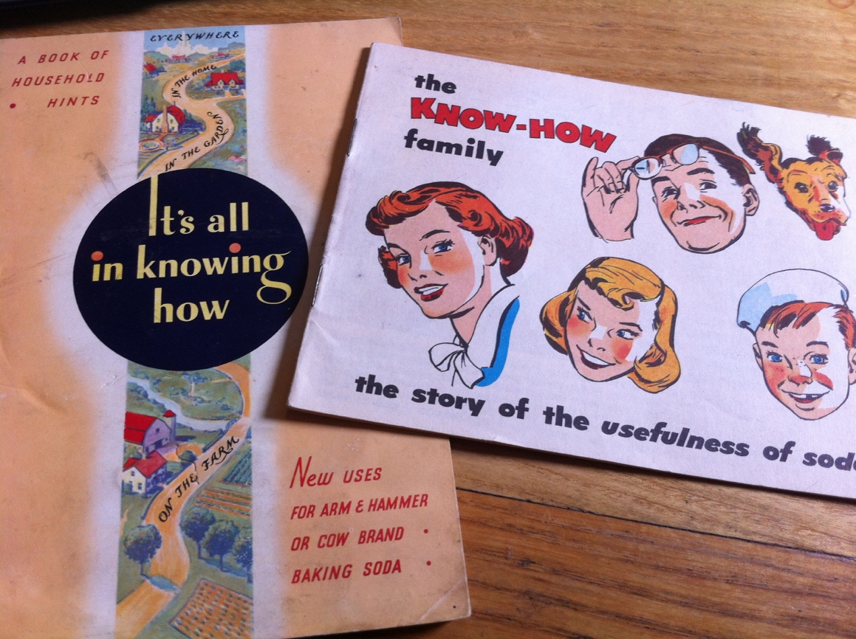

Figure These brightly coloured, attractive booklets were quite different to the comparatively drab British home manuals put out by Harpic and CWS

The expansion from only health and cooking uses to cleaning in the 1930s matched that of the UK and it is hard to say why or how this change was made, or on which side of the Atlantic it occurred first. It does not appear to be related to the American natural resources, deposits of hydrated sodium carbonate and bicarbonate known as the mineral trona, as until 1948 all soda produced in the USA still used the Solvay process. Mining trona meant that the energy-hungry, synthetic Solvay processes could be abandoned in favour of simpler methods of carbonate production.[96] However, the abundance of trona and the cost savings that it facilitated could have impacted on the British producers of sodas by increasing competition through cheaper sodas. As discussed in the washing soda section, ICI informed Boots that it had to raise prices to cover costs of production, which we can see now in the context of trona mines becoming active at around the same time. However, this does not answer the question of why Americans were interested in a wider variety of domestic baking soda uses than the British. In Britain the long established, social image or belief that bicarbonate of soda was for medication, which should be purchased in small quantities in order to not allow it to deteriorate, which was also vital to its leavening ability. While the presence of sodium bicarbonate in the home as a medicament meant that it was then available for other uses, the small quantities it was stored in and used as well as the name, strictly separated it from washing soda which was bought and used in larger volumes. Bicarbonate was advertised as “indispensable for medical and culinary purposes”, but its multitude of other household uses in cleaning were not mentioned.[97]

One recommendation in particular that would have required a sizable quantity, indeed a boxful, was to extinguish a fire by dumping sodium bicarbonate onto it. This safety tip was not included in British publications, as it simply did not match up with the small quantities generally found in the home. Nevertheless, this did not mean that sodium bicarbonate could not be used as a fire extinguisher in the British home. The Selfac fire extinguisher available to British householders in the 1940s incorporated an explosive charge triggered by heat which automatically ruptured the container which released the powder to cover and smother the fire.[98] Nothing about the name indicated that the agent involved would be common baking soda. Other bicarbonate based fire extinguishers were also marketed, both dry powder and a liquid bicarbonate solutions, of varying degrees of effectiveness. A powder bicarb fire extinguisher was even implicated in a robbery when it was allegedly discharged by the perpetrators to temporarily incapacitate the guard while the theft occurred.[99]

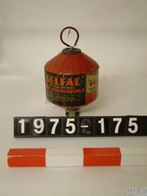 Illustration 2: Selfac fire extinguisher in the collection Science Museum, London

The innocuous kitchen chemical cropped up in political news stories when baking soda solution was supped by Irish prisoners in the Maze when on hunger strike[100] and used to soothe eyes of rioters affected by tear gas deployed in Bogside,[101] a practice that recalled the advice given to civilians in the approach to the Second World War in case mustard gas was used (see Table 1). Later, journalists appeared fixated by the juxtaposition of criminality and domesticity in the use of baking soda for the production of crack cocaine, not an everyday use by any means, but the chemical's role became a consistent feature in reports on the novel drug.[102] There were no calls to attempt to control bicarb's availability because of its part in this minority criminal activity, which would have been futile.

What has been noticeably absent from much of this discussion so far, has been branded goods. Baking soda in the USA was promoted by Church & Dwight as either Arm & Hammer or Cow brands, but there was not a similar strong brand identity in Britain. Baking powder, a pre-prepared mixture of soda and cream of tartar, on which baker’s reputation could be made or broken was a different matter and evidence of many brands can be seen in advertisements and in museum displays. We saw that Carbosil tried to set itself apart from common soda through advertising, and ICI branded washing soda was believed to be well regarded enough to warrant a press announcement to explain the disappearance of the brand, but the same branding was not seen with caustic or bicarbonate sodas. While Alma Chesnut Moore hinted that soda compounds were the basis of favourite household cleansers, she did not illuminate her audience by naming them.[103] In research trips to museums and in searching for evidence of branded goods, I found these domestic chemicals very elusive amongst the ranks of household objects collected for posterity.

### Harpic

One product that was very much in evidence in these collections was Harpic along with other cleaning agents, usually gritty scourers packed in cylindrical tubes. Harpic was not an abrasive product and it was developed to do away with scrubbing one particular household object, the porcelain toilet bowl. As water closets moved into the house, bringing their associated wastes and germs further into the home, the responsibility to keep toilets clean grew stronger which helped to create an eager set of users for Harpic. Washing soda was one of many household chemicals used to clean toilet bowls, and even to scrub the wooden seat snowy white, but Harpic became so widely used it even advertised the fact that it was found in 5 out of 10 WCs.[104] Harpic was not based on washing soda, and it was not based on a chemical that could readily be bought in a generic, unbranded form from the chemist. Harpic was a powder of acid sodium sulphate and when dissolved in the toilet bowl it gave a solution of sulphuric acid. This was particularly effective at removing limescale, which dulled the porcelain bowl and provided a rough surface for dirt to cling to. By removing the limescale, the acid was more effective than bleach, which might temporarily whiten the dingy finish but did not solve the problem of limescale and dirt's affinity for it. This information was not recounted to the user in adverts, which did not mention Harpic's relationship to sulphuric acid or even its particular action on limescale. The adverts described Harpic as the only product that could reach into the bend where the toilet brush could not and that simply leaving it to work, without scrubbing or effort, would result in a glistening, deodorised and disinfected toilet bowl. The 1928 *Harpic Home Book* described “foreign incrustations” rather than limescale and assured readers that it “contains no scheduled poison and is therefore perfectly safe” as opposed to the “dangerous acids” employed before Harpic was available.[105] That in 1966 the ingredients and actions of the cleanser were explained by manufacturers Reckitt & Sons to their advertising agency JWT in a confidential letter suggests that the general public were in the dark about the active ingredient of Harpic.[106]

Harpic was introduced to the market in 1921 by the Harpic Co. who initially sold the powder in cardboard cylinders which were degraded by the acid product. This was quickly rectified by using metal cannisters instead. In 1924, Reckitt's & Sons attempted to purchase the company, but considered the asking price too high. Harpic Co. changed the lid to a sprinkler in 1925, to control the flow of the powder and appear less wasteful. Keen to have such an effective cleanser that had already shown itself to be a favourite with users, by 1932 Reckitt development chemists had developed a potential competitor to Harpic, which placed them in a position to negotiate a more appealing price to buy Harpic Co.[107] For the entire duration of the period this thesis is concerned with, the 1930s to the 1980s, Harpic has been owned by Reckitt's & Sons, later Reckitt's & Colman, and has been a staple product in the domestic bathroom. Harpic advertising changed very little between the 1930s and the 1980s, using highly focused campaigns which concentrated on toilet bowl cleanliness. This specificity was directly related to the chemical composition of Harpic, the acidity of which rendered it suitable only for cleaning “lavatories, or other porcelain or vitreous china articles”.[108]

Despite this acidic property, Harpic was never named in malicious attacks, perhaps not being employed due to the low profile of the active chemical in this product. The chemical’s properities might have come under more scruitiny if Harpic had been involved in accidents where it had been ingested in mistake for something else, but the very well suited containers did not cause the toilet cleaner to be transferred to other containers where it could be mistaken for any edible substance. Even if users had known that they were working with an acid, many would not have known that mixing it with a bleach was dangerous because it released chlorine gas. Some users who believed their combinations made the products work better, the eye-watering fumes that came off signifying their strength and therefore effectiveness.

While most users would have been expected to quickly notice and avoid noxious gases such as chlorine which is very distinctive, all users are different. In 1945, a Birmingham housewife with a damaged sense of smell who, while cleaning her bath mixed half a pint of Parazone with a generous 2oz Harpic, only narrowly escaped serious harm, prompted her doctors to experiment with that mixture to observe the evolution chlorine.[109] They did not call for any further labelling or other action, suggesting that the warnings might be considered reasonable. Yet this type of accident continued. In 1963, of 33 accidental gassings recorded by the National Poisons Information Centre (NPIC) at Guy's Hospital, most of the household cases were from mixing Harpic with a bleach.[110] The trend continued, with 40 out of 45 inhalation accidents reported to the NPIC between 1974-75 relating to liquid bleaches and lavatory cleaners, alone or in combination.[111] The relatively high frequency of domestic chlorine gassing prompted a group of epidemiologists to survey the information given on domestic lavatory cleaners. They found that all twelve different brands bought in their local shop instructed users not to mix cleaning chemicals, but only two (Domestos and Vortex) explained the consequences of mixing.[112] Inhalation of chlorine was not always accidental, as in the case of a 41 year old electrician who mixed Harpic and bleach to inhale the resulting gas for what he described as its pleasurable effects. After several months of this practice, he presented himself at the doctors with severely reduced lung function, worse than was seen in workers chronically exposed to chlorine.[113] However, despite the potential for fatal effects, Harpic appears not to have been used for that end deliberately between the 1930s and 1980s.

Illustration 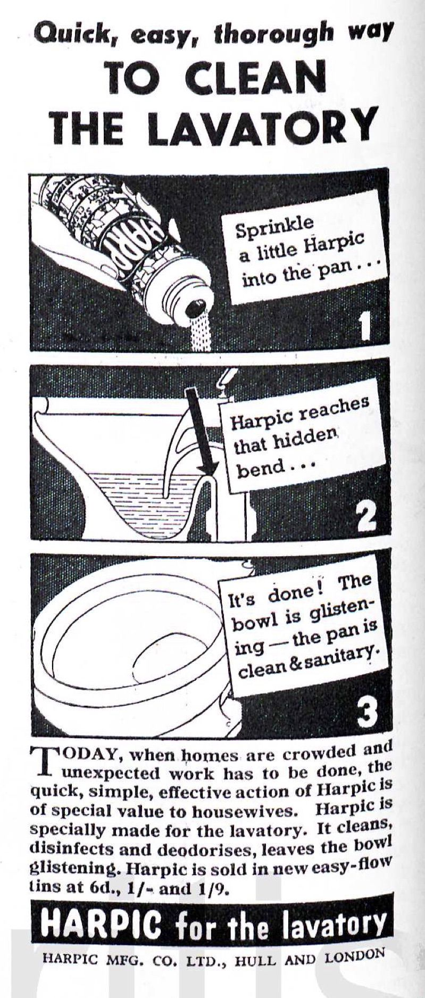3: 1940 advert Harpic as labour saving

Information about the importance of using Harpic alone was reserved for Harpic's packaging and not mentioned at all in its advertising (see Illustrations 3 and 4 as examples), which emphasised that it was the “safe” cleaner. While the accompanying images and exact text varied a little, the adverts always informed the user to expect a “glistening” “shining” “scrupulously clean” “safer than ever” toilet bowl, to use Harpic daily, while emphasising that it was easy and fast to use. The technical drawing of the toilet showing the hidden bend was a staple feature of the adverts which lent them an aura of scientific credibility. In 1950 perfume was added to the product, though existing users were reassured that they could still get the “familiar kind”. Safety of the product user was not mentioned and the manicured hand holding the cannister was not sheathed in a rubber glove, but the safety of the porcelain and the future safety of bathroom users through the disinfectant properties of Harpic were noted.

The user imagined by Reckitts was the housewife, explicitly stated in 1940 and reinforced in their adverts by an image of a feminine hand sprinkling the product into the offending toilet, and the notion of one person in charge of provisioning and enforcing household standards. Regular advertising in women's magazines such as *Good Housekeeping* magazine and daily newspapers such as the *Daily Herald* ensured that messages about Harpic reached a wide variety of women. In the 1950s, advertisements showed a smiling hulk-like man holding the canister of Harpic, but it was not an indication of who would do the work, only that Harpic was as strong as this man with enormous biceps.

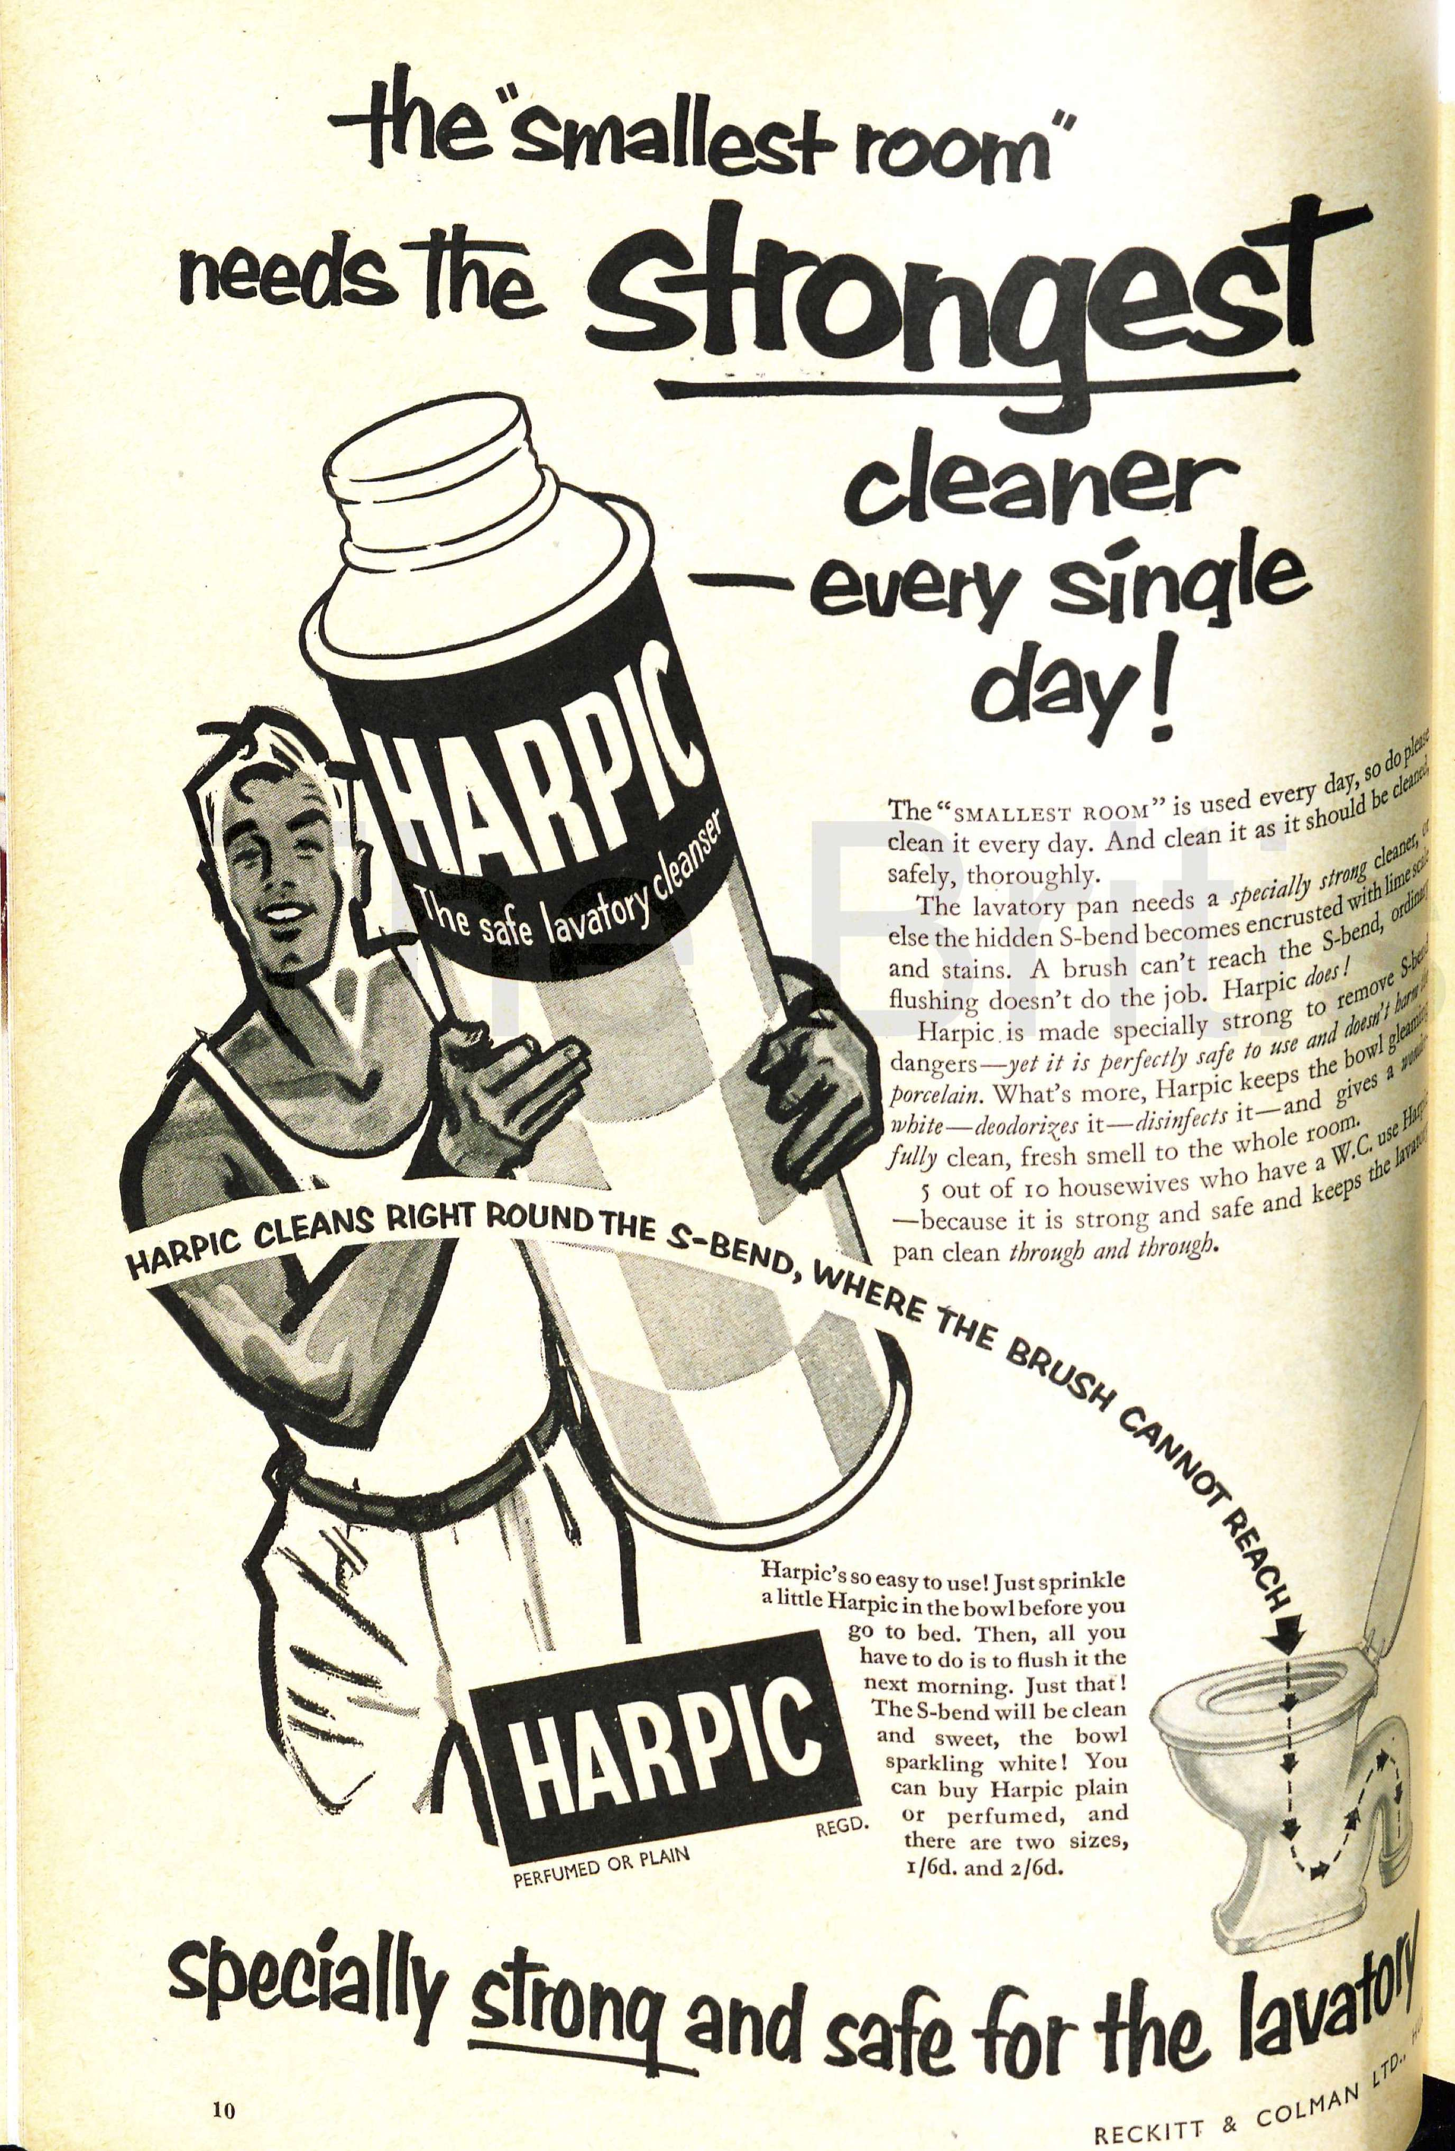

Figure The strength of Harpic is depicted by the image of the strong man, 1955 GH magazine.

While schoolboys might not be the usual audience for toilet cleaner advertising they certainly picked up the gist, and the brand name became an unkind nickname for comedian Simon Fanshaw's teacher: 'We called him Harpic for the simple reason he drove you clean round the bend'.[114] By the 1980s, Harpic was very much a household name in Britain, and used as shorthand for disinfectant or indeed almost any cleaning product, rather than any great understanding of its properties or best uses. Writer Robert Nye recalled his mother in the 1950s wiping down books from the public library with a handkerchief rubbed in Harpic.[115] This snapshot of Mrs Nye who, at least in the eyes of her son, used Harpic not only for cleaning her home in the conventional methods, but also in a way that she believed protected her home, and her family within it, from germs shed by unknown people and their potentially grimy homes that could be borne by the library book. Harpic was evoked when tasting unpleasant foods,[116] and when describing a not very good wine “Jacob's Creek … could to be to wine what Harpic is to toilets”.[117]

The ubiquity of Harpic meant that when Reckitt & Colman were mentioned in media reports of the company's activities, Harpic was routinely given as an example of one of their products that the audience would recognise. Harpic was deemed an anomaly, along with the company's other household cleaning products like Brasso and Windolene, that went against economic theorists' predictions of product life-cycles as it continued to sell well from the 1930s into the 1980s.[118] What these economic theorists perhaps did not take into account was Reckitt's commitment to understanding their product users.

That Reckitt’s were interested in their users’ views can be seen in their choice of advertising agency, JWT, who had a well established research department. By the 1950s Reckitt & Colman were serious enough about the benefits of market research that they had their own unit, one of the very few industrial ones. Users and non-users were surveyed extensively, considering age, family composition, economic status, housekeeping habits and where applicable which competitor or alternative products they used instead of Harpic and why. When Reckitt & Colman recruited for their Commercial Research Department in 1964, the department was described as having its own nation-wide team of interviewers and modern data processing equipment.[119] Their highly gendered person specifications indicate that Reckitt's valued women's communicative ability to draw out useful information from housewives.[120] Reckitt's connection with their product users should be considered an important factor in the successes of the company to develop and market a range of household chemical products that were very well received.

### Carbon Tetrachloride

Carbon tetrachloride (CTC) has been chosen for a case study because it was available before 1930 as both an unbranded product obtained from a pharmaceutical chemist as well the “active” ingredient in a number of branded consumer products, Thawpit cleaning fluid being our principal example in this chapter. Carbon tetrachloride was first synthesised in 1839, by the French chemist Henri Victor Regnault through reacting chloroform with chlorine, which made the chemical of interest to historians of medicine.[121] Historians of chemistry have tended to focus on the changes to CTC's nomenclature, and its experimental role in the development of organic chemistry.[122] This is the first time a history of CTC from the view of the domestic user has been attempted, although military and industrial uses of the chemical have been comprehensively studied.[123]

When CTC was manufactured on a much larger scale as a result of chemical companies searching for an outlet for an excess of chlorine from around 1910,[124] the clear, colourless liquid with a characteristic sweet smell became more widely used in domestic settings.[125] As this thesis is concerned with the period between the 1930s and the 1980s, the status of CTC in the 1930s as a domestic chemical can be considered established, like washing soda and Harpic, but unlike these chemicals, the story of CTC ends with it being actually removed, not just displaced from the domestic market. CTC had been embraced by domestic users as an effective grease remover, promoted as a safer option to using benzine, as it would not catch fire. The vapours were initially described as no more dangerous than benzine, although they could make the user “drowsy” yet by the 1970s CTC was considered the most toxic option of the cleaning fluids then available.[126] As a chlorinated halogen which were becoming implicated in ozone layer destruction at this time, CTC was also pinpointed as a hazard to the environment. The discovery and marketing of other newly synthesised chemicals that were less poisonous, not flammable and highly efficient stain removers began to replace CTC. In addition to this functional replacement, global regulatory systems meant that from the 1970s CTC began to be formally phased out of consumer products to protect the ozone layer, groundwater and human health. CTC has been demonstrated to be carcinogenic in experimental animals, although occupational and population studies of humans are inconclusive, so as a precaution it is considered a potential human carcinogen. Since 2002 it has been banned from consumer products.[127]

Although this chapter is mainly about housework, CTC provides the opportunity to look at some other uses of this chemical in the British home. From 1903 CTC found favour among fashionistas who freshened their hairstyles with the chemical, initially at the hands of professionals in environment of the hairdressing salon, but then also at home by themselves.[128] This makes it one of the earliest uses of CTC in the home. Exactly how the notion of using CTC for cleaning human hair came about has not been clear. It was not recommended in Thawpit's promotional leaflet, though an extrapolation from caring for fur coats and stoles could lead an imaginative user to try it on human hair. Avoiding a full wet wash which before the widespread installation of domestic plumbing and reliable hot water systems might necessitate heating, transporting and disposing of water, as well as the subsequent potentially chilly drying period would certainly have been a benefit of using CTC as a “dry” cleaner for hair.

However, the nature of the chemical and its anaesthetic, cardio-depressant effects meant that this was a fairly short-lived use. During the inquest following an accidental death of a customer having a dry shampoo on their premises in 1909, Harrods hairdressers stated that they had been using CTC without incident for six years, which they estimated to be a total of "20 or 30 000" dry shampoos over this period. This was clearly an expert space, yet when referring to the fatal accident involving the dry shampoo, the hairdressers were framed in the courtroom by medical doctors as non-experts. While the hairdressers may have known how to get results that pleased their clients, they did not have the same level of chemical knowledge as the medics. This was highlighted by the way in which the hairdressers attempted to treat the stricken client who was overcome by CTC during her hair wash, by lying her on the ground to recover. To the scientific men who understood that CTC vapour sunk to the ground, this was the worse possible place to put the patient, who would then surely be further exposed to the suffocating substance. The medics hypothesised that the peculiar, cooling sensation of CTC poured over the scalp, the absorption of the chemical through the skin and the inhalation of the anaesthetic fumes all contributed to the unfortunate woman’s death.[129]

There was no indication of the prevalence of this as a domestic practice but by 1934 the British Medical Journal was able to report that dry shampooing with CTC had stopped as other, safer products had become available.[130] However, it was still employed to clean removable hair pieces worn for personal or social reasons: to hide thinning, balding or alopecia and switches simply worn for styling variety and fun.[131] Dipping the hair into a small saucer of CTC was far safer than having it poured over the scalp, which gave a peculiar cold sensation and it reduced the user's close contact with the chemical so they would be less likely to absorb it through their skin. Additionally the users' active physical position and ability to control the ventilation of the space where they worked, as well as the volume employed all meant that wig cleaning users were less prone to the vapours produced.

The proposed removal of CTC and CTC based products from the market does not appear to have publicly disturbed the wig using population; there were no comments about alternatives or concern about what people were exposing themselves to, and theatre manuals continued to recommend cleaning wigs by dipping them into large containers of CTC well into the 1980s, without warnings about ventilation or toxicity.[132] Surprisingly, a recently revised edition of *Science for Hairdressing Students* listed CTC as a grease solvent which might be encountered, though it warned that all solvents should be treated with respect and used “in plenty of space”.[133] Some wig sellers provide aftercare services allowing users to avoid the question of cleaning and restyling, but the mass production of synthetic wigs in the 1970s was accompanied by care regimes that involved dunking in a gentle detergent shampoos rather than dry cleaning methods, as well as introducing a sense of disposability and reducing the necessity of cleaning.[134]

## Fire extinguishers

The other example of CTC in the home is contained within fire extinguishers, where more often than not it was hoped to never actually be used. The same property of CTC vapour being heavier than air which could be fatal to humans also meant that it was fatal to fire. As a liquid, CTC cooled the fire and also denied it oxygen, plus as a heavier than air vapour it blanketed the fire and further starved it of oxygen. Extinguishing devices came in a variety of forms, including the now familiar pressurised extinguishers, produced by various manufacturers from 1918. These brass cannisters were also joined by fire grenades, in which the chemical was visible in glass balls or tubes, often hung on the wall in a purpose-built bracket. Some were quite plain globes, others more elaborate and aesthetically pleasing, which has ensured that some have been collected by enthusiasts. Vogue magazine carried a photograph and description of a swan-shaped grenade in 1947.[135]

Illustration 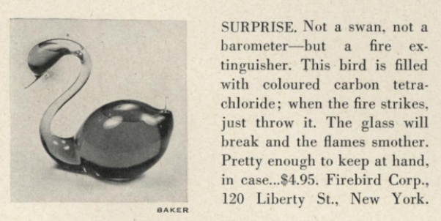5: Fire grenade pictured in US Vogue 1947

The grenades were sealed shut, preventing evaporation of the volatile chemical, but also ensuring that the CTC was only used for fire prevention rather than extracted from the grenade for any other domestic purpose. These sealed glass vessels were intended to be thrown at the base of a fire, breaking the glass and releasing the liquid. Alternatively, automatic versions could be installed which dropped the globe when heat destroyed a component of the holder. From the relatively small number in British museums, other collections or second hand, they do not seem to have been very popular. This may have been due to their fragility so they have not survived to be collected, their contents difficult to dispose and dangerous to store, or they really were only a minor part of domestic firefighting, with water or sand being cheaper to tackle small fires.

CTC could be used to put out any kind of fire, which was useful in the rapidly modernising British home which was at risk from fires started by candles and oil lamps, solid fuel fires or gas, electricity, or even incendiary bombs dropped during WWII. Due to its non-conductive nature it was particularly useful for electrical fires,[136] although CTC extinguishers have not featured in histories of domestic electrical technologies. Historian Emily Hankin's work on domesticating electricity as the National Grid expanded covered tripping over flexes and electrocution, but did not raise the concept of electrical fire risk in the home, for instance from overloaded sockets.[137] Graeme Gooday's work on the history of electric lighting explains that the electrical companies' focus on the safety and lack of worry compared to the fire risks from gas in the home, led the dangers of domestic electrical fires to be downplayed, as not requiring a special technology to deal with them.[138] This should not be surprising, as the emphasis on safety of electricity does not lend itself to thinking about the terrifying damage that an electrically started fire can wreak, or the problems associated with treating it like a normal fire. illustration is one of Pyrene's early British adverts from 1919, when they specifically highlighted children at home as requiring protection. The fire extinguishing liquid was not named, but neither was it obfuscated by any other terms or descriptions. The user was assured that it would not damage fabric or furniture when the efficient and easy to use extinguisher put out the fire.[139]

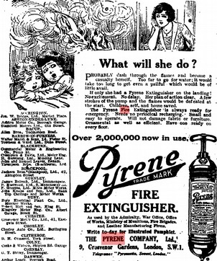

Figure A domestic scene where the mother could use the extinguisher to save her children, self and home.

A letter to *The Times* shows that CTC extinguishers were not regarded by users as completely trouble-free. Alexander Duckham wrote in 1934 that his experience as a chemist meant that after waking feeling unwell, he could identify the smell in his bedroom in which he hung “a standard type of car fire extinguisher” as that of CTC. This phrasing confirms that the active ingredient of the fire extinguisher was not made obvious to the user on the object itself, and that someone training in chemistry would not be able to locate the source of the problem as the fire extinguisher, so Duckham took on the duty to translate his experience for people with less chemical expertise than himself.[140] He does not consider that people may have encountered CTC outside a chemical laboratory, despite recommendations to householders that they could use CTC as a domestic grease solvent beginning from the mid to late 1920s. No further comment was made on the incongruity of a product which promised to protect material objects whilst potentially poisoning the user.

By the 1930s Pyrene's British promotional material ignored the domestic aspects of fire prevention and focused instead on the material and financial aspects of cars and property, rather than lives or a sense of security. Although air raids in the First World War stimulated the promotion of Pyrene extinguishers for domestic use,[141] this was not repeated in the following conflict in the face of greater devastation wrought by more powerful bombs, and recurrent raids and associated fires which made water and a stirrup pump a more convenient, cheaper option to recharge when repeatedly faced with fires. Pyrene's later British advertising pamphlets focused on non-domestic masculine images, depicting fire extinguishers in soldiers' vehicles, in military aircraft, in racing cars, and called on the authority given to the extinguishers by their visible presence in public institutions and on public transport (see illustration below).

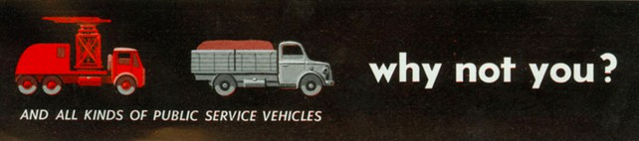

Figure Pyrene, 'An investment into peace of mind' asked 1950s homeowners “why not you?”.

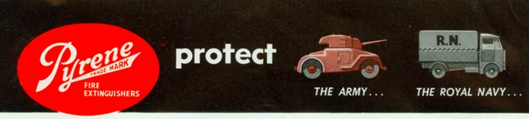

Pyrene instructed users to immediately refill the extinguisher even if the fire was put out in two or three strokes of the extinguisher. The user was instructed to refill, rather than to take the product to a specialist to be refilled, the 1950s pamphlet indicates that CTC was sold to domestic users for this purpose. However, in these advertisements the chemical name was never given and instead referred to the “special liquid” or “fire killing liquid”. This gap in knowledge would invariably be filled by the Pyrene sales representative, as users could be expected to work out from the description that it was safe for use on electrical fires, that it was non-conductive and would not freeze, as well as should not be used in a confined space that these were all clues to this mystical “fire extinguishing liquid” being CTC.[142]

It eventually became evident that CTC was not appropriate to use in all fire situations because when in contact with hot metal, it produced phosgene gas and chlorine. Although this was reported in the medical press from 1946,[143] it was not picked up on in the mainstream news, and therefore the general user population, until many years later. Newspapers reported on industrial accidents where this happened in the 1960s, such as those at a Sheffield steel mill[144] and Leeds engineering works.[145] These incidents were not explicitly linked to to domestic fire extinguishers, although relevance to the British home was hinted at by the definition of a confined space being given as "a cellar or living room" and saying that there are a million of this type of extinguisher in use throughout Britain,[146] which suggests their presence in private homes as well as in public transport and industrial situations. The generation of phosgene in a domestic fire was probably far less likely than in an industrial situation, but the presence of CTC vapour in a confined space was also dangerous.

## Household cleaning

In comparison to hairdressing and firefighting, advice to use CTC for household cleaning became widespread somewhat later, between the mid to late 1920s and the early 1930s. That CTC was not very widely used is confirmed by its absence from 5th edition of Wynter Blyth's book on poisons published in 1920 which contained many other chemicals commonly found in the British home.[147] The mass production of CTC, discussed briefly at the start of this section, provides a clue as to its relatively limited uses before the late 1920s, so while technically it was a very useful grease remover it would only be used for household cleaning tasks once it was manufactured at a volume that made it available at a suitable cost for regular use. Unbranded CTC was presented in 1926 as “readily procurable” but without indication of from where, though we can suppose that people were familiar with asking their chemist for such items.[148]

A branded form of CTC, Thawpit, was created by Captain Thomas Thorpe in the 1920s. Although “BMG” in Somerset wondered whether the name Thawpit stemmed from “thawsty”, a dialect word meaning nauseatingly dirty,[149] it is likely that the product was more ego-centrically named for its similarity to Thorpe. Indeed, Thorpe-it sounds very similar to Thawpit, which was what adverts in 1928 encouraged users to do: “Thawpit your ties and suits”, using the very brandname as a verb.[150]

Undated leaflets produced by Thawpit probably in the 1920s set out the ways in which the solvent could be used as a multipurpose grease remover. The leaflet extolled the potential for general household uses including “removing verdigris from geysers”, as well as the masculine cleaning activities of polishing car headlights and removing tar from car bodies or tobacco pipes. This multipurpose appeal could be expected to sell Thawpit to a wide range of users, who would rapidly use up the product if they followed the advice in the leaflet and used in all these situations. No doubt CTC was effective at these tasks, but when compared to other more readily available, cheaper alternatives that were as effective, the product came across as trying to be too much.

In 1934 Thorpe engaged advertising agency J. Walter Thompson (JWT), the same user-focused agency that Reckitt’s hired to handle Harpic, to handle promotion and labelling of the brand.[151] Looking to maximise the volume of Thawpit that would be used, JWT instigated regular market surveys of existing users which asked about textile in particular, as well as to general grease removal. JWT found that very few users cleaned whole garments at home, they used Thawpit for spot cleaning and generally bought it when they needed it or slowly used a bottle they kept on hand. Their research suggested that focusing on textiles, rather than all the other household uses for Thawpit, would be beneficial. Broader market research carried out in both in the UK and US on dry cleaning revealed that most domestic users did not realise the process involved total immersion in a liquid and did not know that this liquid could be reused after the removed dirt settled as sediment.[152] Although Thorpe wanted them to promote home dry cleaning which would use a larger amount of Thawpit, JWT resisted this request and found a compromise that would not confuse, or endanger home users who attempted to work with a chemical that could make them “drowsy”.

JWT aimed to increase the frequency of cleaning, and therefore the rate that CTC was used up so bought again, by moving away from only removing stains to encouraging users to give a “going over” to a garment before it got really dirty, which meant being ready to refresh the whole surface. Users were instructed to pay particular attention to high-wear, visible areas such as collars, cuffs and shirt fronts. After a very utilitarian campaign which showed either a men's suit or a women's outfit on a hanger (Figure 9),[153] JWT developed a campaign that added an emotional tagline for the previously purely factual content of Thawpit advertising. “X marks the spot” showed a man aghast after noticing dirt on his date's clothing, which quashed any romantic feelings or future (Figure 10).[154] This campaign capitalised on social anxiety and used the well-established advertising trope of suggesting that others will scrutinise and rapidly judge you on the state of your attire. These adverts included the distinctive hexagonal bottle, along with a description of how to apply it using a piece of fabric, which was described as a rag in the advert directed at men's suits and as a clean cloth in the advert which directly addressed women.

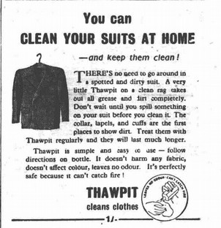

Figure JWT's functional appeal to men

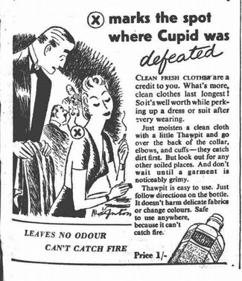

Figure JWT's emotional appeal to women

The containers that Thawpit was sold in also determined how the product was used at home. Illustrations 8 and 9 above include an image of the bottle, which was glass, colourless, clear, and distinctively hexagonal, stopped with a cork. The cork was later replaced by a screw top. Two sides of the bottle were ridged, a well established tactile and visual signal used on bottles containing poisons and this message was reaffirmed by the embossed phrase “Not to be taken”. A warning to not breathe the vapours was included on the paper label fixed to the remaining three smooth sides of the bottle, which instructed users to keep the bottle tightly corked (in order to prevent evaporation and wastage) and to avoid using it in confined or unventilated places. The presentation of the solvent in a volume that facilitated meagre usage, rather than encouraging immersion of an object and reuse of the solvent, made hard by the narrow neck of the bottle would not be easy to return the liquid to. Nevertheless, this simple bottle afforded users more freedom to use the solvent in other ways if they wanted to.

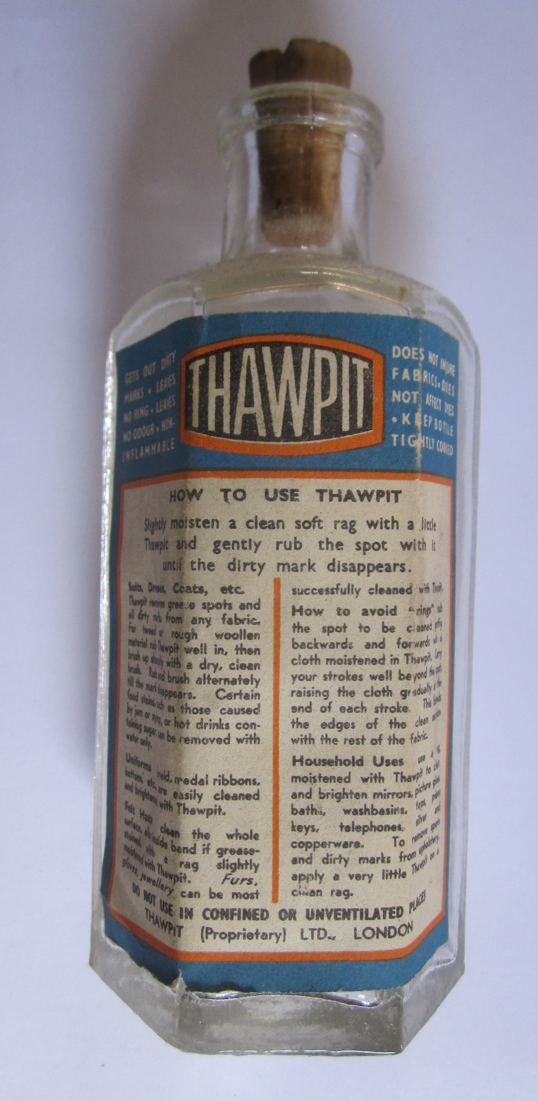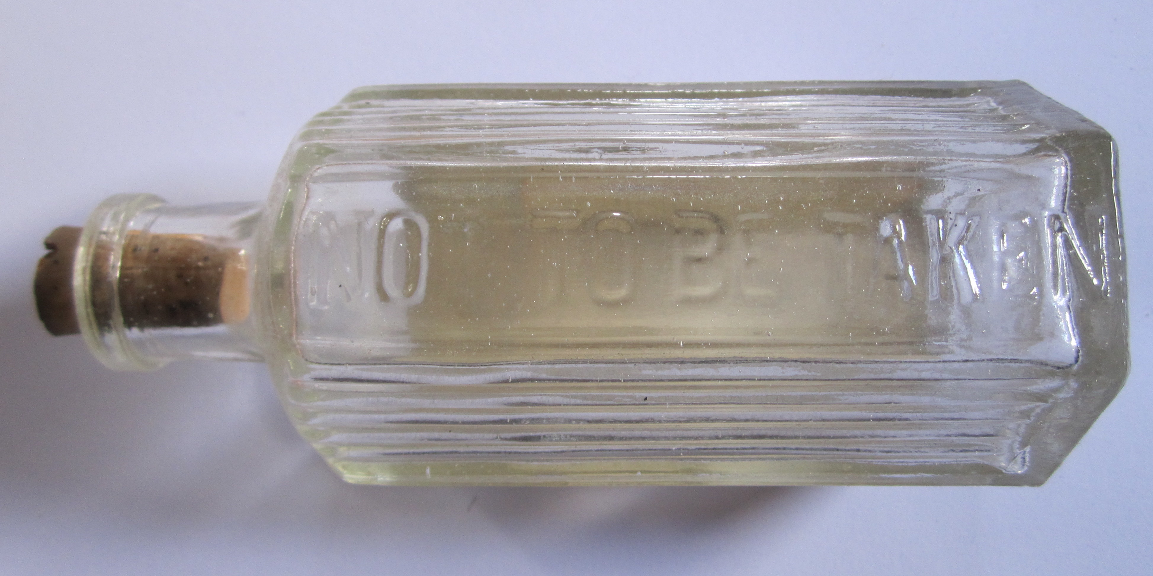

Figure Thawpit bottle (unknown date) but similar to the one shown in the 1940s adverts which were still corked. Embossed ridges and “not to be taken”

This freedom can be compared to applicator tips, a packaging innovation that reinforced a single use for the product, that it should be applied to spots on clothes, rather than applied to a cloth or emptied into another container (Illustration 9). Both activities combined with inattention or carelessness had been associated with fatal accidents.[155] If a user accidentally knocked over a bottle of solvent, the applicator pads also stopped so much from escaping.[156] Competing brands had pads fixed to the top of their bottles while Thawpit sold applicator tips separately. In an internal Boots catalogue which promoted the idea that shops should assemble Spring Cleaning displays, the price of Thawpit was listed as 1/9, or 6 shillings for a larger size, with the separate cleaning pad to fit the small bottle as 1/3 and 2 shillings for the large one. Competitor Dabitoff, with its built in cleaning pad was priced at 2 shillings sixpence.[157] This presentation and price differential allowed Thawpit to appeal to users who either did not want or need an applicator pad, or were able to reuse them. The choice of an applicator pad or not meant that more options in how Thawpit could be used and for what, rather than only being for removing grease spots on textiles, was left open for the user to decide.

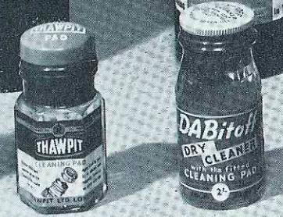

Figure Taken from an internal Boots magazine (1954), this image shows Thawpit’s new packaging to clean directly with the pad attached to the bottle, although the recognisable hexagonal shape was retained..

Keen to understand what Thawpit was, as well as what it did, JWT asked for more information on the grease remover. Thorpe explained that it was the same chemical in fire extinguishers.[158] Although Thawpit's labelling and informational leaflets did not state what the cleaner actually was, the characteristic odour, qualities and precautions to take when using it identified it to a chemically knowledgable user as being CTC based. Letters between Thomas Thorpe and JWT reveal that Thawpit cleaner contained CTC made by Albright & Wilson.[159] Thawpit was pure CTC, unlike other CTC based products which contained detergent, or were a mixture of solvents.[160]

The benefit of buying Thawpit over a bottle of CTC from the chemist was that the user also bought a great deal of information about how to best use it. The comprehensive instructions were revised with reference to new synthetic textiles and updated to account for fashion. However, the reader of Thawpit's promotional material would have been left in the dark about the identity of the miraculous fluid. Household hints articles and manuals sought to educate their readers to make economical choices when they referred to CTC, or unnamed proprietary chemicals, but they did often did not help their readers identify which brandnames they should look out for. This mismatch demonstrates how users were expected to be curious about new products and able to assimilate information from multiple places, joining the dots and filling in the gaps for themselves to work out what was in proprietary products.

Household hints columns never presented CTC or an equivalent branded preparation as the only option, instead it was the final solution when the mark did not succumb to more common treatments of soap or ammonia.[161] The prioritisation of simpler, more readily available methods in these recommendations also show that older methods were not rejected or even fully replaced when a new product became available to domestic users. Getting a mark out quickly, possibly with something already to hand was of more importance than exactly what chemical was used to remove it. Cost was another factor which writers of these tips took into account, offering petrol and benzine as cheaper, although flammable alternatives.[162] The ready availability of petrol, either sold in tubes from tobacco kiosks at least into the 1940s, or obtained from cars meant that Thawpit had to be as easy to obtain in order to compete.[163] Availability of petrol, or rather its rationing meant that Thawpit was promoted as the ideal replacement. Not only that, but it helped extend the life of clothing which was also rationed. JWT's advertising also emphasised the lack of smell and absence of fire risk inherent in using the cleaner, properties that without out actually naming petrol referred to the drawbacks of that option. I did not find any signs that access to CTC was restricted during wartime, which is the opposite to the situation in the USA. Civilian supplies were severely limited so that barely sufficient volumes could be used industrially and militarily.[164]

Knowing about, selecting and being able to obtain a new chemical was not enough for domestic users. For best results, CTC had to be applied in a particular way, to mitigate the development of a ring around the stain. The method of applying CTC could determine whether a user was satisfied or not with the result, which meant that manufacturers of proprietary dry cleaners worked hard to provide comprehensive instructions on the correct techniques to use. Explanatory booklets full of diagrams accompanied their products and the same textual information appeared in these household tips columns. This meant that instructions that accompanied branded goods were not necessarily the only way to become informed about how best to use it CTC. Nevertheless, satisfaction with the end result was a major concern to keep users loyal to Thawpit, and instructions were regularly revised in light of information from users.[165]

As well as stain removal, Thawpit was involved in a very large variety of alternative uses albeit by a minority of users. During JWT's market research users volunteered that they used it to remove tar and grease from skin, but also to remove nail polish, to prevent chilblains, or if they were walking a lot they rubbed it on the soles of their feet, plus it was used as a garden spray and on windows to keep flies away.[166] No rationales accompanied these insights into these imaginative users, so the logic of preventing chilblains remains a mystery. Although these off-label uses remained strictly as curiosities and were not encouraged or perpetuated through any promotional work, JWT's survey revealed the diversity of methods and products that people employed to remove grease marks and other stains at home (see Table 2). Market research, as well as less formal 'asking round the office' also repeatedly found that Thawpit's main competitors were ammonia and petrol, rather than similar branded CT-based products, such as Beaucaire.[167] There was some frustration and incredulity that housewives had not picked up on the non-inflamability of Thawpit, but excused by their personal experiences of having not caught fire before, or that they 'do not hanker to clean near a naked flame'. The lack of awareness of Thawpit's main benefit indicates that reducing fire risk was not the housewives' main reason for choosing it. Being able to get the product at a number of different shops and being satisfied with the results were more of a priority than fire safety. [168]

|  |  |  |
| --- | --- | --- |
| **Other agents or methods mentioned by respondents used to remove grease in 1950** | | |
| **Chemical** | **Branded product** | **Other methods** |
| Ammonia  benzine  carbon tetrachloride  chloroform  oxalic acid  paraffin  petrol (including lighter petrol)  pine and ammonia  powdered magnesia  methylated spirits  salt  spirits of salts  turpentine  vinegar  water | Beaucaire  Cleenitoff  Clensel  Dettol  Domestos  Dry Magic  Eukleen  Goddard's Dry Process Cloth Ball  Hedley's Cleaner  Inaflash  John Lewis cleaner  Kenmal  Kleenit  Kleneze  Klenox  Klengene  Klo  Klosklene  Liquid Glass  Little Old Chap  Mel  Milton  Modene  Moval  Neufaline  Octin  Parazone  Persil  Renu  Restatus  Revyvit  Sisipinda  Spectoral  Spik  Sprim  Sposs  Susie  Triko  Vim  Woolworths cleaner  Zodil | Blue water  boiled ivy leaves  brown paper and hot iron  carpet soap  cloth ball  cold tea  dried bread crumbs  French chalk  Fuller's Earth  hot bran  tea leaves |

Table 2: The number of branded products is greater than both the unbranded chemicals and other methods using household items.[169]

Table 3 is taken from a six page guide to stain removal in a 1975 *Good Housekeeping* (GH) magazine,[170] here the grease-related items have been extracted. Articles like this were regular features in GH and other women's magazines, and each gives a snapshot of the materials, knowledge and activities that might be be found in the British home. Twelve branded grease solvents were named, along with four unbranded options. These were French chalk, talc or Fuller's earth, suggested as absorbent agents, and the plant-based eucalyptus oil. These natural substances were not further explained, while the branded, chemically synthesised, solvents were accompanied by warnings. However, natural-ness was not an issue that was singled out in this encyclopedic approach, and neither was any anti-chemical attitude apparent. Household chemicals were to be treated carefully and respectfully, as useful aids 'handy to have around' to the housekeeper devoted to a stain-free life.

While Thawpit would have recommended their product as appropriate for all the situations listed, the tests run by the GH team meant that they only chose to name Thawpit for a limited number of scenarios. It was deemed particularly suitable for treating Dralon fabrics, an acrylic textile popular since the 1950s. The fibre composition of 'unwashables', such as tents and camping equipment or beachwear are not mentioned, which is a departure from the detailed knowledge about textiles that those in charge of household laundry appeared to be expected to have. Articles like this, with their exhaustive breakdown of stain scenarios, the varied approaches and the almost overwhelming visual effect of the sheer volume of information laid out in column inches, act as a proof of the complexity of ordinary, everyday domestic situations that a user would face. Succeeding in this complex arena with so many 'wrong' choices to be made would give the user of domestic chemicals a sense of satisfaction.

|  |  |
| --- | --- |
| **Scenario: Grease, Fats, Oils** | **Method or *Proprietary Product*** |
| Table linen | Blot, wash at high temp |
| Other washables | Scrape, wash at high temp or use grease solvent.  *Polyclens Plus* or *Swarfega Hand Cleanse*r |
| Upholstery/non washables | French chalk, talc or starch alternatively  *Dabitoff Spray Spot Remover*, *K2R*, *Polyclens Plus* |
| Flat woven and velvet pile Dralon | *Thawpit* |
| Not Dralon or pile | Warm iron then e.g. *Beaucaire* |
| Leather shoes | *Meltonian stain remover*, or *Meltonian Mel Grease and Tar Remover* |
| Suede shoes | *Meltonian Mel Grease and Tar Remover* |
| Suede coats | *Delu Suede cleaning cloth* (do not use liquids) |
| Wallpaper | Warm iron over blotting paper followed by, eg *K2R* |
| Hessian | Aerosol grease solvent, sparingly |
| Carpets | Blot/scrape, then *Polyclens Plus, Goddard's Dry Clean or Beaucaire* |
| Tents and camping gear | *GoPro Tent Cleaner* |
| Beachwear | Eucalyptus oil or *Targon* |
| Hair oil on upholstered headboard | Dralons respond best to *Thawpit* or *Goddards Dry Clean* |

Table 3: This shows the continued proliferation of branded grease removers and that one product was not considered applicable to all grease removal situations. Thawpit was specifically recommended in only two scenarios, with eleven other branded alternatives named.[171]

Although GH did not sanction it, even in 1971 petrol was still being used for domestic cleaning despite its economic advantage over branded products being 'doubtful'. From a report compiled on the explosives accidents which included the inevitable accidental fires associated with using such a substance in the home, the gender of those involved in petrol related domestic cleaning accidents was reported ambiguously, through the use of words such as 'occupier' and 'user'. This is in stark contrast to the abundant masculine descriptors employed when reporting petrol related accidents in the workplace. Domestic accidents were recorded tersely: 'occupier attempted to clean tar off a pair of trousers with petrol. Trousers were left near gas water heater. Petrol vapour was ignited by pilot light'. 'Petroleum spirit used for cleaning interior of motor vehicle. User lit a cigarette and petrol vapour ignited.' However, the compilation of mishaps provided an example of a man undertaking cleaning the carpets in his kitchen and had been seriously injured when the gas pilot light ignited the vapours.[172] In all these cases, the users had diligently been working to clean up but had not fully thought through their whole situation, so had not noticed or not connected the presence of flames or fire with the possibility of petrol vapour ignition. It is interesting that no rationale, other than economic, was conjectured or sought from the users involved in these accidents. JWT's market research showed that even in households with low income Thawpit was used, so this cannot have been the only reason. The way that Thawpit advertising principally targeted women could perhaps have been a factor if it meant that petrol was more likely to be used by men. Maybe these petrol users were trying to avoid what they perceived as the drawbacks of using CTC, such as the harmfulness of vapours in enclosed spaces and its increasingly dubious status as benign as it became suspected as a carcinogen.

After Thawpit's emotional X Marks the Spot campaign, women continued to be the main target of Thawpit advertising when in 1951 JWT launched a huge print advertising campaign and even placed an advert in the *Chemist & Druggist* to prepare its readers, the sellers of Thawpit, for the increased demand that widespread advertising was hoped to generate which urged them to keep the grease remover on display. They described the breadth of the advertising coverage as "7 national daily newspapers, 6 national Sunday newspapers, 3 London evening newspapers, 5 leading provincial newspapers, the Radio Times, 12 women's weekly magazines, 11 women's monthly magazines."[173] This blanket coverage was comprehensively inclusive, set to reach almost every segment of the printed media perusing public.

This strategy continued in 1966 when magazines including Woman, Woman's Own, Woman's Realm, Woman's Weekly and Reader's Digest were targeted as Thawpit released a new design of bottle that incorporated a cleaning pad.[174] The selection of magazines clearly shows that the advertising agency and manufacturer identified middle and working class women as important in the decision to purchase and use Thawpit, especially with the improved functional packaging. By March 1973, Thawpit was promoted as a budget-friendly alternative to sending garments out for dry cleaning and Thawpit adverts made 74 million 'opportunities for sales' through the *News of the World* alone.[175] This newspaper was founded with the intention of appealing to a large readership through its low price, meaning it achieved massive circulation and reached many working class potential users.

### Relative safety

CTC vapours had initially been deemed no more harmful than benzine, which professional dry cleaners understood to be a potent nerve toxin, but this was outweighed by the advantage of not being susceptible to catching fire. [176] Likewise for domestic users, who may not have been quite so well informed as the professionals, any dangers inherent in using the chemical were outweighed by its effectiveness at removing grease and the dirt carried with it. They wanted the promise of clean, long lasting clothes and so appear to have accepted the negatives along with the cons. The consequences of not following any warnings about ventilation and vapours were not spelled out to the domestic user. That users were capable of estimating that the consequences would be severe from the shorthand warnings not to take the chemical was demonstrated when CTC was deliberately ingested or inhaled in suicides. CTC was not classed as a 'favourite' poison, only as a less common option and by the mid 1960s a 'perhaps diminishing' choice.[177] In these examples, it is interesting to note that despite being generally described as a cleaning fluid in these incidents, those who engaged CTC with suicidal intent at home were male, a group typically thought of as using more violent methods, rather than domestic and therefore feminised household cleaning chemicals.

CTC's lethality even inspired fiction and an example of this can be found in Leslie Charteris' short mystery story *A Cleaner Cure*, where the lethal effects of this common, household chemical were put to use. A medical doctor discussed CTC with the protagonist, The Saint, who expressed surprise at such a widely used chemical: 'Why aren't people dropping dead all the time?. The fictional medic conceded that 'It's a wonder it doesn't happen more often. Everyone thinks carbon tet is harmless, but that's because it doesn't catch fire or explode'. The Saint mused about CTC as a murder weapon, and the medic pointed out that its use would be detected by visible effects on internal body fat.[178] In practice pathologists tended to first pick up on CTC's involvement by its characteristic smell,[179] but the appearance of CTC as a fictional murder weapon in shows that tensions regarding utility and lethality were perceived.

Fortunately, CTC seems only to have been used in anger against plants, rather than to deliberately harm other people. A local flower show in Macclesfield came to national attention when one of the competitors found the chrysanthemums he had been growing for the occasion poisoned by CTC fumes and suspected sabotage from a chemically knowledgeable opponent, as this flower appeared to be uniquely susceptible to the chemical vapours. CTC was described as an 'everyday chemical' which was widely used in the town's silk industry,[180] but did not mention any other possible sources of the chemical, raising suspicions that it was someone connected with the textile trade.

These warnings did not always translate to avoiding accidental poisoning, because users could store the small bottle wherever they chose at home, they could handle it carelessly, or for whatever reason, they may decant it into another container.[181] In reports of accidental poisoning, it was often noted that the victim had also drunk alcohol either previously or afterwards, and this exacerbated CTC 's damaging effects on the liver and kidneys.[182] Nevertheless, improved labelling of CTC cleaning fluids was discussed in the Houses of Parliament in 1965, which appears to have been a turning point in British awareness about the safety of CTC despite the long precedence of incidents and evidence of dangers associated with the chemical. It also seems to have been the only attempt to influence this set of household chemicals, which were not subject to any other formal regulation with regards to their composition. Consumers demanded an end to deceptive packaging sizes and clarity on weights and measures so that they could be certain of value for money, but safety of the products contained with in was not so much of an issue. The Home Department requested that the labels on this type of cleaning fluid added the advice to keep out of reach of children and that most manufacturers already carried warnings against inhaling the vapour or using it in a confined space.[183] Still, in the 1970s, not all manufacturers listed the ingredients of cleaning fluids, leading Moore to stress to users that they should pay attention to descriptions of nonflammable or flammable, then to treat any nonflammable solvents as CTC, that is, with the “utmost care”.[184]

There was barely any discussion until the 1980s about the wider shared environmental potential problems with CTC in British newspapers or magazines, which neither called for, supported or bemoaned any proposed removal of CTC specific products, although it did occasionally report their disappearance.[185] Where CTC was classed as a pollutant, it was only ever in terms of industrial discharge, rather than connected to domestic use.[186] The view on domestic safety of chemical products seems focussed on the individual, where CTC users appeared to shoulder the responsibility for safety, stoically accepting that if they contravened the manufacturers' or suppliers' warnings, then they were responsible for making the choice to use it unsafely. Only in regard to deliberate solvent abuse has evidence surfaced of awareness raising campaigns led by the press, or letters to MPs from bereaved family members, despite the regularity that fatal accidents from normal use occurred. Pressure from the USA over uncertainty regarding the possible long term environmental risks associated with CTC's persistence in the atmosphere and damage to the ozone layer, it's presence in ground water and possible cancer risks associated with exposure, stimulated the withdrawal of CTC but these were not concerns aired amongst British users or consumer reviewers. Ambivalence amongst users to its withdrawal or increasing unavailability was perhaps to be expected when there were so many alternative products and methods at their disposal.

As well as the development of products for the domestic market, we also saw CTC transition from a chemical that was used professionally by hairdressers and dry cleaners, to one that was also used in the domestic sphere. It provided, and proprietary versions were marketed as, an alternative to flammable grease solvents such as benzene or petrol, but other than packaging, no changes were made to the chemical itself to make it safer for domestic users. The benefits of buying a branded product such as Thawpit was that it came with instructions on how to use it, whereas a bottle of CTC from a chemist would not. Surveys of Thawpit users and non users did not identify unbranded CTC as a main competitor, indicating that Thawpit users did not switch once they became familiar with the product. Thawpit could be sold at many outlets, conveniently picked off the shelf, without the need to queue and interact with a retail chemist as it was decanted and labelled.

### Conclusions

At the beginning of this chapter, categories of users were introduced in Neathercoat’s demands for greater household chemical safety, all of them were met and several new ones, imaginative, expert and experimental, added. We have seen that users shared their experiences of buying and using chemicals in various printed media and used this platform to question products. User needs and practices were gauged by market research, carried out by advertising agencies or the manufacturers themselves. Users were interested in effectiveness and value for money, and it was not unusual for chemical users to be ignorant of the associated safety benefits of their choice or to use the product in a way that made it unsafe. Concern for knock-on domestic and global environmental effects of product choices arrived so late to the scene in Britain that they have not been discussed in this thesis. In the case of CTC, the choice to avoid this chemical was taken out of users hands through its worldwide removal. Although some chemicals used in the household were on the Poisons List and subject to controls, the majority of them were not and there were no calls for them to be more tightly regulated or tested either. Histories of vivisection are hazy about household products and usually discuss cosmetics rather than chemicals not marketed to be applied to or ingested by humans. Indeed, the influence of British government and industry regulation on domestic products is generally lacking, while American systems, admittedly concerning of cosmetics, pharmaceuticals and agricultural chemicals and only vaguely applied to cleaning products, are much better characterised. This is partly excusable when globalised companies and worldwide standardisation are considered, but it is still important to understand what is special about British users, as they are undoubtedly different, exposed to different influences, living with different domestic infrastructures and technologies at different times to households in the USA.

Chemicals with a long history of use as domestic cleaning agents and the particularly harmful ones were associated with medical or legal case studies and gruesome anatomical specimens. These were not on general public view, so accounts of accidents or crimes which appeared in the news or fictional representations were how chemical dangers were disseminated more widely than the victims’ immediate populace. On the whole users knew and accepted that certain chemicals such as caustic soda could be harmful when kept or employed carelessly. However, when buying a new branded product, users were not always clear about exactly how cautious they should be, or why. Users took cues from the type of product as much as any specific packaging or labelling, that a product for washing up or laundering would be suitable to immerse hands in, products for cleaning very dirty ovens or toilets should be strong and therefore not suitable to get on bare skin. It was in the interests of the manufacturing company making a product that users could be expected to use comfortably, but how they established this remains uncommented on in company histories, and an area for further research in the future. Doctors experimented for themselves to understand user mishaps, as we saw in the Birmingham case of accidental gassing with Harpic and bleach.

The chemicals chosen for these cases studies did not stimulate any dedicated safety awareness campaigns about household chemicals in general, despite repeated problems with burns from caustic soda, inhalation of chlorine gas evolved from improperly used Harpic, and CTC vapour. Where concern was raised, it was for unsupervised children who may ingest caustic soda or suffocate themselves with CTC, rather than the intended adult users. While the severity of the consequence of mixing Harpic and bleach could have been explained, it is possible that not doing so prevented despairing users from interpreting this warning as a method for self destruction. Only when the lethality of such mixtures became fully labelled did this form of self poisoning become popularised in the 2000s.

This chapter introduced the concept of relative safety, where Harpic was an alternative to using and storing dangerous liquid acids in the home, and CTC or Thawpit could be safer than using a flammable grease remover such as petrol. Thawpit could be safer than a bottle of CTC from the chemist because its applicator top prevented spills if it was knocked over. However, user safety was not entirely altruistic. Branded products promoted as safer options could be sold more widely by many unspecialised retailers, rather than just registered pharmacists. They were more convenient to users who grew used to self service and not waiting for advice or warnings to be dispensed. Users were used to well established shorthand warnings such as “not to be taken”, even if the consequences were not spelled out. They were educated haphazardly of what could happen through stories of misadventure relayed between acquaintances and through newspapers.

A sense of user behaviour as difficult to control in the home emerged in this chapter, but that this could be reasonably successfully dealt with through packaging and labelling. Making packaging a key feature in the successful use of a branded product, such as Carbosil’s pouring packet, Harpic’s sprinkle-lidded canister, and CTC-based products applicator tips, can direct or encourage users into desired behaviours. This chapter also showed the polar opposite of presentation of soda crystals and bicarbonate of soda and unrestricted user behaviour. The principal constraints were conceptually linked to the common names, washing soda and baking soda, but users were able to make up the strength of solution that they wished or to combine it with other products and to use on any surface or object that they desired, without ill effect. Harpic users were given less freedom than soda users, though they could still use more to make a stronger solution, or mix it with other chemicals, but there did not seem to be an issue with decanting the powder or mistaking its identity.

Language both shapes and reflects ideas so looking at the use of certain phrases in news media has been a starting point for my research. The results for searches for “household chemicals” and “domestic chemicals” shows that these phrases turned up most often in adverts for products that could resist or withstand such things: ICI plastic homewares, Chevrus “teak grained melamine” furniture. People, or users of chemicals in the home were far more rarely the subject of what household chemicals acted on, although hands were vulnerable to household chemicals, potentially soothed by Neodex ointment and Cuticura cream. These instances reveal that household chemicals had a reputation for being harsh, for stripping the colour out of plastics, the oils out of skin, or upsetting the balance of a septic tank through over use, avoidable with SeptaPlan. This absence of editorials or letters about household chemicals cannot be interpreted as all chemicals used in the home were believed by users to be benign. That women’s hands were aggravated by contact with household chemicals was taken for granted, soft, pale delicate hands are a staple advertising feature working to show that the product does not redden and roughen.Where there were negative effects from certain chemicals or groups of chemicals, these were dealt with specifically, as seen with solvents that could be abused, CFCs that depleted the ozone.

Household “poisons” or “toxins” were the phrases used when chemicals used in the home were also believed capable of dire effects on human inhabitants. In the case of poisons, chemicals became poisons only in combination with careless human behaviour. Toxins on the other hand were beyond the control or will of users, perhaps seeping out into the domestic air from synthetic materials or carried in as a residue, uninvited and unexpected chemicals in the domestic interior, the unintended consequences of using some other product. The effects of the toxins were uncertain, but expected to be unpleasant, possibly contributing to cancer or long term health effects. (Appdx householdchemicalsDM)

1. Grace Higgens, housekeeper to artist Vanessa Bell did not record using any products or chemicals, simply noting "distempered out larder, looking very nice" "scrubbed through" "polished" "very busy cleaning" (Add 83220), though it was remembered that she did not use liquid detergent for washing up despite Fairy being available. Jean Michie, artificial intelligence researcher, recorded various brand names in her shopping lists and accounts: Vim Flash appeared with Rennies, Alkaselzer alongside unspecified brands of deodorant, gin and 'fags'. Add MS 88958/5/13
2. Moore, Alma Chesnut. *How to Clean Everything: An Encyclopedia of What to Use and How to Use It*. London: T Werner Laurie Ltd, 1954.
3. Newstead, John. *A Pharmacist's Tale*. John Nickalls Publications, 2003, p55. This was a cough mixture, but the principle is applicable to other products
4. Neathercoat, E.T. "Poisons in the Home." *The Daily Mail*, 02 January 1926, 6.
5. "The Parent Company and Its Interests in the United Kingdom." edited by Imperial Chemical Industries: Catalyst, 1950.
6. Letter from Davies, P. "Thawpit, ICI." Boots, 1964.
7. Moore, Alma Chesnut. *How to Clean Everything: An Encyclopedia of What to Use and How to Use It*. London: T Werner Laurie Ltd, 1954
8. Musson, A.E. *Enterprise in Soap and Chemicals: Joseph Crosfield & Sons Limited 1815 -1965*. Manchester, UK: University of Manchester, 1965. (p158,159, 198).
9. Carbosil. "Advertisement." *The Sunderland Echo and Shipping Gazette*, 23 March 1932, 6.
10. "Spots and Stains." *The Manchester Guardian (1901-1959)*, 1927 Jun 15 1927, 8.
11. Beeton, Isabella. *Mrs. Beeton's Hints to Housewives; with Sections on Labour-Saving, Household Work, Servants' Duties, Shopping, Table Service, Etiquette, and First Aid*. 1928, p41
12. Duckham, Alexander. "Removing Stumps of Oaks." *The Times*  (28/07/1930 1930): 18.
13. "Dandelions." *The Manchester Guardian*, 01/07/1936 1936.
14. "An Antirrhinum Menace: How Gardeners Should Combat It." *The Manchester Guardian*, 21/03/1936 1936.
15. Lucio. "Miscellany." *The Manchester Guardian (1901-1959)*, 1930 Feb 26 1930, 9.
16. "The Monster: A Kitchen Transformation." *The Manchester Guardian*, 02/11/1932 1932.
17. "Infested New Houses: Salford's Measures National Campaign Possible." *The Manchester Guardian*, 12/12/1933.
18. "Vacuum Flasks." *The Manchester Guardian (1901-1959)*, 1932 Jun 16 1932, 6.
19. "Science and Housekeeping: Some Small Points." *The Manchester Guardian*, 27/08/1935 1935
20. "Science and Housekeeping: Some Small Points." *The Manchester Guardian*, 27/08/1935 1935.
21. "Iodine Stains." *The Manchester Guardian (1901-1959)*, 1933 Jul 10 1933, 6.
22. "'Jews Keep out' Sign on Links." *Daily Express*, 11 July 1938, 1.
23. "Mantlepiece Stains." *The Manchester Guardian*, 08/11/1934 1934.
24. "Scorch Marks." *The Manchester Guardian (1901-1959)*, 1934 Feb 22 1934, 6.
25. "Saving Fuel." *The Manchester Guardian (1901-1959)*, 1939 Sep 21 1939, 4.
26. "Cooking Economies." *The Manchester Guardian (1901-1959)*, 1939 Nov 02 1939, 4.
27. L, M. "Economies in the Kitchen." *The Manchester Guardian (1901-1959)*, 1940 Jul 24 1940, 3.
28. "Reducing the Effect of Poison Gases." *The Times*, 07.01.1935 1935, 9.
29. "Summer Stains." *The Manchester Guardian (1901-1959)*, 1935 May 22 1935, 6.
30. "Stockings." *The Manchester Guardian (1901-1959)*, 1935 Jun 13 1935, 6.
31. "Washday Hints." *The Manchester Guardian (1901-1959)*, 1937 Jun 30 1937, 8.
32. "The Garden in August." *The Manchester Guardian (1901-1959)*, 1938 Jul 23 1938, 8.
33. "Stocking A.R.P. Larder." *The Manchester Guardian (1901-1959)*, 1939 Jul 14 1939, 15.
34. "The Ministry of Food." *The Times*  (06 November 1941): 7.
35. "The Ministry of Food." *The Times*  (04 April 1944): 3.
36. Settle, Alison. "Women and the Raids." *The Observer (1901- 2003)*, 1940 Oct 06 1940, 2.
37. "The Manchester Assizes: A Lover's "Brutal Revenge"." *The Manchester Guardian*, 24/04/1940 1940, 10;
38. "Imperial Chemical Industries Limited." *The Times*, 27/06/1941 1941, 3.
39. "Bomb disposal team destroys World War II extinguisher in Longniddry" 04 June 2013 <http://www.bbc.co.uk/news/uk-scotland-edinburgh-east-fife-22775253>
40. "Winter Spraying: Fruit and Other Trees." *The Manchester Guardian*, 30/11/1940 1940.
41. "Any Questions?". *British Medical Journal* 1, no. 4607 (23 April 1949): 734-36.
42. "Put Caustic Soda in Fish Tanks." *The Manchester Guardian (1901-1959)*, 1953 Nov 27 1953, 4.
43. Harris, E. "Chilblain Treatment." *Derby Daily Telegraph*, 19 January 1950, p5.
44. Moore, Alma Chesnut. *How to Clean Everything: An Encyclopedia of What to Use and How to Use It*. London: T Werner Laurie Ltd, 1954 p43
45. *A "Practical Householder" Handbook*. London: George Newnes, 1962.
46. "New Lines." *The Guardian (1959-2003)*, 1963 Apr 15 1963, 4.
47. Hilary, Gelson. "Cool Calm and Collected." *The Times*  (09 July 1970): 8+.
48. Boseley, Sarah. "Blackmailers Spiked Baby Food." *The Guardian (1959-2003)*, 1989 Apr 27 1989, 1.
49. Erlichman, James "ICI Admits Green Labels Were Wrong." *The Guardian (1959-2003)*, 1990 Jun 07 1990, 2.
50. L, M. "Economies in the Kitchen." *The Manchester Guardian (1901-1959)*, 1940 Jul 24 1940, 3.
51. "Shoes at the Seaside." *The Manchester Guardian*, 07/08/1934 p6
52. Dixon, Joan, and Kathleen E. Fletcher. 3rd ed. London: Pitman, 1974.
53. Carbosil. "Advertisement." *The Sunderland Echo and Shipping Gazette*, 23 March 1932, 6.
54. Musson, A.E. *Enterprise in Soap and Chemicals: Joseph Crosfield & Sons Limited 1815 -1965*. Manchester, UK: University of Manchester, 1965. (p158,159, 198).
55. Kelley, Victoria. *Soap and Water: Cleanliness, Dirt and the Working Classes in Victorian and Edwardian Britain*. London: Tauris, 2010, p50
56. Reeves, Pember. *Round About a Pound a Week*. The English Working Class. New York: Garland Pub., 1980. (p60)
57. Reeves p61
58. Carbosil. "Advertisement." *The Sunderland Echo and Shipping Gazette*, 23 March 1932, 6.
59. "Imperial Chemical Industries." *The Times*, 17 October 1940, 3.
60. Musson, A.E. *Enterprise in Soap and Chemicals: Joseph Crosfield & Sons Limited 1815 -1965*. Manchester, UK: University of Manchester, 1965 p346
61. "Where's All the Soda?". *Daily Express*, 05 October 1949, 3.
62. "Improved Supply of Meat Urged ". *Evening News*, 08 February 1950, 6.
63. "Soda." *Dover Express*, 10 February 1950, 16.
64. Woolworth's. "Woolworths." *Daily Express*, 06 February 1959, 11.
65. Woolworth's. "Woolworth's." *Daily Express*, 25 February 1965, 6; Seaton, Paul. "Woolworths Museum: Launch of Winfield Own Brand." <http://www.woolworthsmuseum.co.uk/1960s-ownbrands.htm>
66. Davies, P. "Letter from Drugs Buying Office, to D.H. Moore Retail Price Department - Re. Thawpit, Ici." edited by Boots the Chemist, 2: Boots, 1964.
67. Boots. "Household Products Survey: Trends in and the Future for Household Cleaning Products." edited by Boots: Boots, 1968.
68. Carbosil. "Advertisement." *The Sunderland Echo and Shipping Gazette*, 31 May 1933, p4.
69. Boase, Tessa. *The Housekeeper's Tale*. London: Aurum Press, 2015, p260
70. Standring, Heather. "It Pays to Clean Thoroughly." *The Observer (1901- 2003)*, 1966 Mar 27 1966, 28.
71. Standring, Heather. "The Pleasures for Smoking." *The Observer (1901- 2003)*, 1965 Dec 05 1965, 31.
72. Conran, Shirley. *Superwoman : Everywoman's Book of Household Management*. 2 vols London: Sidgwick and Jackson, 1975.
73. Nuttall, Nick. "ICI Accused of 'Green' Deception." *The Times*, 07 June 1990, 6.
74. Philip, Howard. "Camping as Life of Luxury with Inflatable Furniture and Ingenious Gadgets." *The Times*  (1972/01/27/)
75. Wynter Blyth, Alexander , and Meredith Wynter Blyth. *Poisons: Their Effects and Detection*. 5th ed. London: C. Griffin & Company, 1920. p128
76. Pharmacy & Poisons Act, 1933
77. “He Went to Buy Bicarb - Got Caustic Soda Instead." *Daily Mirror*, 24 June 1949
78. *Miss Leslie's Magazine*, quoted in *Crinolines and Crimping Irons* p 32
79. Pearn, J., J. Nixon, A. Ansford, and A. Corcoran. "Accidental Poisoning in Childhood : Five Year Urban Population Study with 15 Year Analysis of Fatality." *British Medical Journal* 288, no. 6410 (1984): 44-46.
80. Craig, J. O. "Emergencies in General Practice: Poisons Children Swallow." *The British Medical Journal* 2, no. 4954 (1955): 1496-98.
81. Fraser, Neil C. "Accidental Poisoning Deaths in British Children 1958-77." *The British Medical Journal* 280, no. 6231 (1980): 1595-98.
82. "Ten Calls for Ambulance: Bolton's Bad Night." *The Manchester Guardian*, 04/08/1937.
83. "Children Burned by Caustic Soda." *Daily Mirror*, 10 July 1969 1969, 1.
84. "Boy, 3, Ate Caustic Soda." *The Guardian (1959-2003)*, 1963 Jun 25 1963, 16.
85.
86. Watson, Katherine "Loss of Face - Vitriol Throwing in Nineteenth- and Twentieth-Century Britain" paper delivered at Crime and Legal History Seminar, Oxford Brookes, 27 March 2013
87. "Woman Burned by Acid." *The Manchester Guardian*, Jan 14 1949, 8.
88. Trace, T. "Personal View." *The British Medical Journal* 2, no. 6090 (1977): 825.
89. "You Too Can Be a Stripper." *The Observer*, Apr 23 1967, 32.
90. Fisher, Tom. "A World of Colour and Bright Shining Surfaces: Experiences of Plastics after the Second World War." *Journal of Design History* 26, no. 3 (2013): 285-303.
91. Horsfield, Margaret. *Biting the Dust: The Joys of Housework*. Palgrave Macmillan, 1999.
92. *Harpic. The Harpic Home Book*. London: Harpic Manufacturing Company 1928; *C.W.S. Household Hints*. CWS publishing company limited, 1930s.
93. *It's All in Knowing How*. USA: Church & Dwight, 1935. promotional booklet.
94. *The Usefulness of Soda*. USA Church &Dwight, 1952. promotional booklet.
95. "Imperial Chemical Industries." *The Times*, 17 October 1940, 3.
96. Bureau of Land Management "Trona." US Department of the Interior <http://www.blm.gov/wy/st/en/field_offices/Rock_Springs/minerals/trona.html>.; Coalition, Minerals Education. "Sodium Carbonate (Soda Ash or Trona)." https://www.mineralseducationcoalition.org/minerals/sodium-carbonate-soda-ash-or-trona.
97. "At Home or Away Boots Helps You Save." *Hartlepool Mail*, 14 August 1953.
98. Scottish Fire and Rescue Service "Museum of Fire: Historic Firefighting Equipment 1940s." http://www.firescotland.gov.uk/museum-of-fire/historic-firefighting-equipment/1940s.aspx.
99. "Man Charged with Wages Theft: Guard Says He Was Sprayed with Powder." *The Guardian (1959-2003)*, 16 Jan 1963, 22.
100. Niesewand, Peter. "Hard and Last Rules." *The Guardian (1959-2003)*, 1981 Jul 14 1981, 17.
101. Jackson, Harold. "Police in Derry Use Tear Gas and Armour." *The Guardian (1959-2003)*, 1969 Aug 13 1969, 1.
102. Browne, David. "Crack." *The Observer*, 24 July 1988, 15.; Dudman, Graham, and Sue Johnson. "Crack Peril Hits Britain." *The Daily Express*, 23 January 1989, 2.
103. Moore, Alma Chesnut. *How to Clean Everything*. London: Tom Stacey Ltd., 1972.
104.
105. Harpic. *The Harpic Home Book*. London: Harpic Manufacturing Company 1928.
106. Richardson, G.D. "Harpic Formula." 2: History of Advertising Trust, 1966. HAT 50/1/147/3/2/7
107. Reckitt, Basil N. *The History of Reckitt and Sons Limited*. London and Hull: A Brown and Sons Limited, 1951.
108. JWT 5/9/1, HAT Archive.
109. Malone, I. J. S. D., and J. F. Warin. "A Domestic Case of Chlorine-Gas Poisoning." *British Medical Journal* 1, no. 4383 (1945): 14.
110. Crook, J. C. "Some Hazards of Accidental Gassing." *Medicine, Science and the Law* 6, no. 1 (1966): 29-36.
111. Goulding, Roy, G. K. Ashforth, and H. Jenkins. "Household Products and Poisoning." *The British Medical Journal* 1, no. 6108 (1978): 286-87.
112. Philip, Robin, Caroline Shepherd, Fiona Fawthrop, and Bill Poulsom. "Domestic Chlorine Poisoning." *The Lancet*, no. 31 August (1985): 495.
113. Rafferty, P. "Voluntary Chlorine Inhalation: A New Form of Self-Abuse?". *British Medical Journal* 281, no. 6249 (1980): 1178-79.
114. Fanshawe, Simon. "Grouchy Harpic and Cha-Cha... And Me." *The Guardian*, 29 August 1990, 32.
115. Nye, Robert. "A Literary Goldmine Behind the Men's Socks." *The Times*, 10 July 1970, 8.
116. Downing, Beryl. "Experts Expound on the Proof of Puddings." *The Times*, 10 December 1983, 15.
117. Daniel, John. "Chateau Oz Comes of Age." *The Guardian*, Mar 25 1989, 11.
118. Cowe, Roger. "Mustard Men Turn Hot-Foot to Their Strongest Tradition." *The Guardian (1959-2003)*, 1988 Apr 08 1988, 16.
119. Reckitt & Colman, "Market Research Officer." *The Observer*, 11 October 1964, 17.
120. Reckitt & Colman, "Market Research Supervisor." *The Guardian*, 12 November 1968, 11.
121. McKenzie, A. G. "Carbon Tetrachloride as an Anaesthetic." In *History of Anaesthesia Society Autumn Scientific Meeting*, 7-11. Chequer Mead Arts Centre, East Grinstead, 2003.
122. Ihde, Aaron J. *The Development of Modern Chemistry*. Courier Dover Publications, 1970. p217-218; Rocke, Alan J. *The Quiet Revolution: Herman Kolbe and the Science of Organic Chemistry*. University of California Press, 1993.
123. Morrison, Robert D., and Brian L. Murphy. *Chlorinated Solvents: A Forensic Evaluation*. Royal Society of Chemistry, 2013; Smith, Mark G. "Preliminary Study of Sources of Carbon Tetrachloride Final Report." 233: GCA Corporation GCA / Technology Division, 1983. 2-5; Doherty, Richard E. "The Manufacture, Use and Supply of Chlorinated Solvents in the United States During World War Ii." *Environmental Forensics* 13, no. 1 (2012): 7-26.
124. Aftalion, Fred. *A History of the International Chemical Industry*. Chemical Heritage Foundation, 2001. p117; Morrison, Robert D., and Brian L. Murphy. *Chlorinated Solvents: A Forensic Evaluation*. Royal Society of Chemistry, 2013. p160; "Proposed processes" DIC/BM 20/150/31 1903-1907 ICI; Archives of Brunner, Mond and Company Ltd and its subsidiaries, Cheshire and Chester Archives and Local Study Services.; Podger, Hugh. *Albright & Wilson: The Last 50 Years*. Sudley: Brewin Books Ltd, 2002. p3
125. Smith, Mark G. "Preliminary Study of Sources of Carbon Tetrachloride Final Report." 233: GCA Corporation GCA / Technology Division, 1983. 2-5
126. Brannt, William. *The Practical Dry Cleaner, Scourer and Garment Dyer*. 4th ed. Philadelphia: Henry Carey Baird & Co, 1911, p19; HAT 50/1/175/2 memo by GA Holdsworth 19th March 1935; Moore, Alma Chesnut. *How to Clean Everything*. London: Tom Stacey Ltd., 1972, p173.
127. Toxicology Department. "Carbon Tetrachloride - General Information." Public Health England, 3, 2009.
128. "An Anaesthetic Shampoo." *The British Medical Journal* 2, no. 2438 (1907): 764-65.
129. "The Dangers of the 'Dry Shampoo'." *The Times*  (25/08/1909): 2.
130. "Carbon Tetrachloride Poisoning." *The British Medical Journal* 1, no. 3829: 953-54.
131. "Four Heads on One Girl." *The Daily Mail*, 05 December 1964, 7.
132. Young, Douglas. *Create Your Own Stage Faces*. Prentice-Hall Trade, 1985.
133. Lee, CM, and JK Inglis. *Science for Hairdressing Students*. 3rd ed.: Elsevier, 2014.p62
134. Baker, Patricia. *Wigs and Make-up for Theatre, Tv and Film*. Routledge, 2012; Valmor. "Advertisement: Valmor High Fashion Wigs." *Ebony*, June 1973.
135. "Shop Hound: Marksman." *Vogue*, 1947 Sep 15 1947, 119
136. Our Insurance, Correspondent. "Fire Prevention." *The Times*, 14/06/1933, 11.
137. Hankin, Emily. "Buying Modernity? The Consumer Experience of Domestic Electricity in the Era of the Grid." University of Manchester, thesis, 2012.
138. Gooday, Graeme. *Domesticating Electricity: Technology, Uncertainty and Gender 1880-1914*. Pickering and Chatto, 2008.
139. "Advertisement: Pyrene Fire Extinguisher." *The Manchester Guardian*, 12 December 1919, 12.
140. Duckham, Alexander "Fire Extinguishers Indoors." *The Times*  (13/04/1934): 10.
141. "Zeppelin Raids." *Derby Daily Telegraph*, 23 September 1915, 1.
142. "An Investment into Peace of Mind." The Pyrene Company Ltd, 1950s.
143. "Poison in Fire Extinguishers." *The British Medical Journal* 1, no. 4768 (1952): 1122-23. This refers to van Oettingen, Nat. Inst. Hlth. Bull No. 185 discrediting CTC as a fire extinguisher.
144. "Firemen Give a Killer Gas Warning." *The Daily Mirror*, 1965, 3.
145. "Gas Fumes Put 71 in Hospital." *The Daily Express*, 1960, 1.
146. "Firemen Give a Killer Gas Warning." *The Daily Mirror*, 1965, 3.
147. Wynter Blyth, Alexander , and Meredith Wynter Blyth. *Poisons: Their Effects and Detection*. 5th ed. London: C. Griffin & Company, 1920.
148. "Spots and Stains." *The Manchester Guardian (1901-1959)*, 1926 Jan 01 1926, 6.
149. BMG. "Queries." *Somerset County Herald*, 23 November 1944, 2.
150. Thawpit advert, Western Daily Press, Bristol, June 15 1928, p5.
151. HAT 50/1/175 Sub-series description in Admin History.
152. "The Home Market for Fabric Tints and Dyes, Spot Cleaners, Rug and Upholstery Cleaners." In *Thawpit*, edited by McCall Corporation: History of Advertising Trust, 1951.
153. JWT. "You Can Clean Your Suits at Home." *Northern Daily Mail*, July 24 1945, 6.
154. JWT. "X Marks the Spot." *Northern Daily Mail*, 16 June 1946, 7.
155. Foxell, A.W.H. "Three Cases of Carbon Tetrachloride Poisoning with One Fatality." *The British Medical Journal* 1, no. 4703 (1951): 397; "Deadly Duster Kills a Girl." *The Daily Express*, 15 May 1958.; "Smell Kills Boy Aged 6." *The Daily Mail*, 20 October 1962, 6.
156. "Stain Removers." *Which?*, February 1964, 61-64.
157. Boots. "Spring Cleaning Products." edited by Boots. Nottingham: Boots Company Archives, c.1954.
158. HAT 50/1/175/2 memo by GA Holdsworth 19th March 1935
159. HAT 50/1/175/1 Advance material for Thawpit Review Board 31st December 1951 (meeting 7th January)
160. Polson, C. J. . "The Role of the Pathologist in the Investigation of Fatal Poisoning." *Medicine, Science and the Law* 5, no. 4 (1965): 203-10; Moore, Alma Chesnut. *How to Clean Everything*. (1972) p174
161. "Autumn and the Furniture." *The Manchester Guardian (1901-1959)*, 1926 Nov 18 1926, 6.
162. "An Oil Remover." *The Manchester Guardian (1901-1959)*, 1930 Oct 16 1930, 8.
163. HAT 50/1/175/2 Questions on Thawpit, 18 Sept 1941; Letter from ME Mackendrick to Mr Boulter, Mr Hinks, Mr Stansbury 10 March 1942
164. Doherty, Richard E. "The Manufacture, Use and Supply of Chlorinated Solvents in the United States During World War Ii." *Environmental Forensics* 13, no. 1 (2012): 7-26.
165. HAT 50/1/175/2 notes on report AW Parker 11May 1951
166. HAT 50/1/175/3 Thawpit Consumer Investigation 1945, British Market Research Bureau Limited
167. HAT 50/1/175/2 Letter from ME Mackendrick to Mr Boulter, Mr Hinks, Mr Stansbury 10 March 1942; HAT 50/1/175/1 Market Research Report 1950
168. HAT 50/1/175/2 Market Research report 3 May 1951, notes on report AW Parker 11May 1951
169. HAT 50/1/175/1 Market Research Report 1950
170. Kent, Cassandra, and Gillian Smedley. "Out, Damned Spot! GHI's Guide to Stain Removal." *Good Housekeeping Magazine*, September 1975.
171. Kent, Cassandra, and Gillian Smedley. "Out, Damned Spot! GHI's Guide to Stain Removal." *Good Housekeeping Magazine*, September 1975.
172. "Report of Her Majesty's Inspectors of Explosives for the Year Ended 31st December 1970." London: Home Office, 1971. p41
173. "Get Set to Clean up with Thawpit!". *Chemist and Druggist*  (01 September 1951): 2.
174. "Press and Publicity." *Chemist and Druggist*  (11 June 1966): 599.
175. Advertisement, *Chemist & Druggist* 10 March 1973, 297.
176. Brannt, William. *The Practical Dry Cleaner, Scourer and Garment Dyer*. 4th ed. Philadelphia: Henry Carey Baird & Co, 1911.
177. "Today's Drugs: Treatment of Acute Poisoning: 1." *The British Medical Journal* 2, no. 5414 (1964): 927-29.
178. Charteris, Leslie. *Trust the Saint*. The Saint. London: Hodder and Stoughton, 1962. (Thanks to M. Rowland for this tip)
179. Polson, C. J. . "The Role of the Pathologist in the Investigation of Fatal Poisoning." *Medicine, Science and the Law* 5, no. 4 (1965): 203-10; "Tent of Death." *The Guardian (1959-2003)*, 1984 Jan 21 1984, 2.
180. "Prize Flowers Poisoned." *The Daily Mail*, 03 November 1947, 3.
181. Smith, D.H.K. "Carbon Tetrachloride Toxicity." *The British Medical Journal* 2, no. 5475 (1965): 1434.
182. Foxell, A.W.H. "Three Cases of Carbon Tetrachloride Poisoning with One Fatality." *The British Medical Journal* 1, no. 4703 (1951): 397.
183. HC Deb 26 April 1965 vol 711 cc20-1W
184. Moore, Alma Chesnut. *How to Clean Everything*. London: Tom Stacey Ltd., 1972.
185. "'Glitter' Chemical Banned." *The Guardian (1959-2003)*, Aug 14 1979, 2.
186. Elkington, John. "Chemistry's Peaceful Solution." *The Guardian (1959-2003)*, Dec 03 1981, 15; Brown, Paul. "Chemicals in Water Linked to Harwell." *The Guardian (1959-2003)*, 1990 Mar 23 1990, 3.